Pictures Taken During Region February 2018 Region Luncheon:
Posturing for Best Seats Takes Skill: 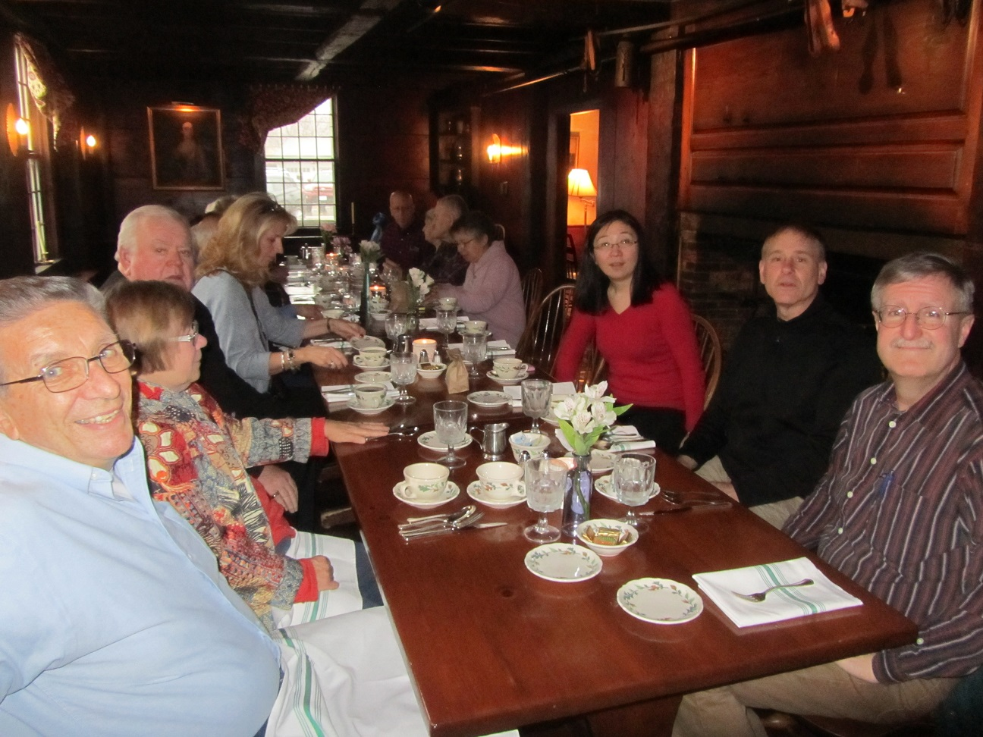
Region Member Takes Over Serving A Hungry Crowd:
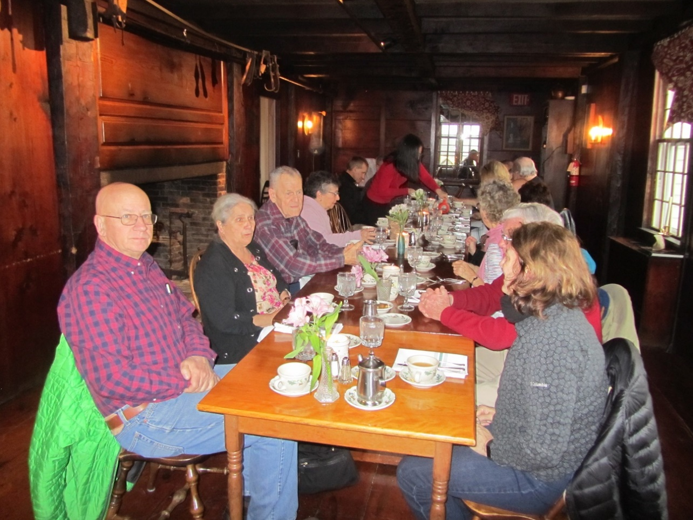
President sits near the center to be heard at both ends of the table (it didn’t work for such a long table):
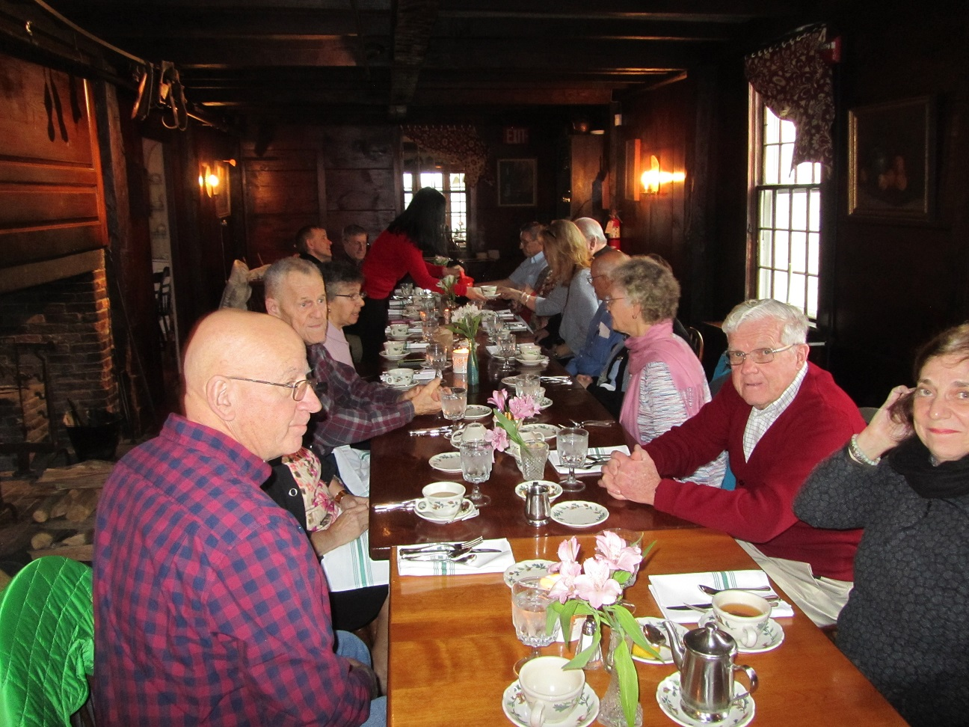
See the Secretary Minutes for the meeting decisions on the budget, planning for future meets, and informational announcements.
After the meeting we toured the Restaurant with Colonial Period Décor fit for a meeting of the Colonial Region.

