Some Pictures Taken During Region Dec. 2017 Holiday Party:
Posturing for Best Seats Takes Skill:
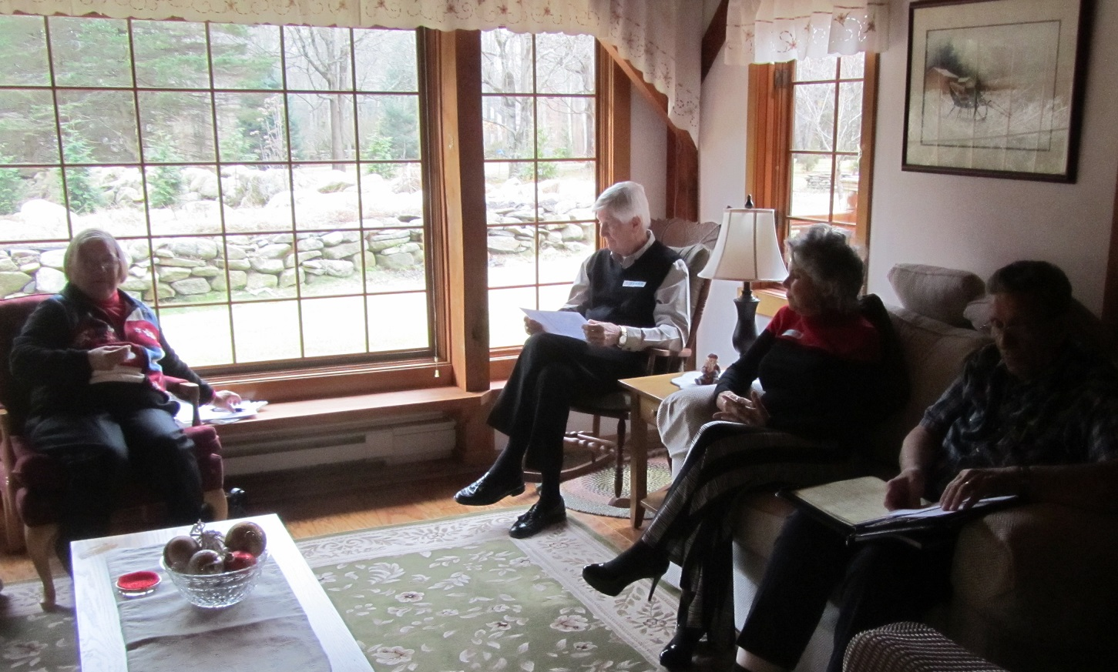
President Organizes The Troup After Eats For Formal Meeting:
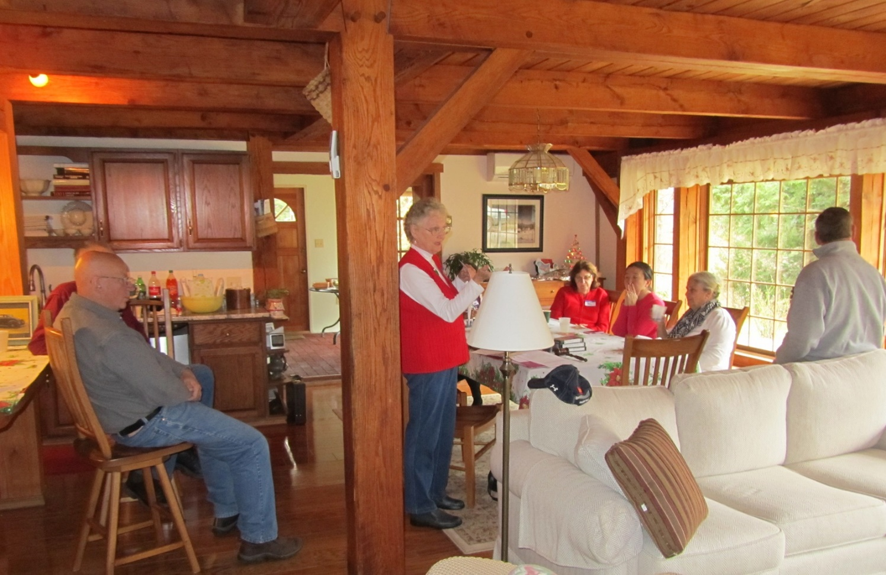
President Message Is Short Since All Are Anxious About Gifts:
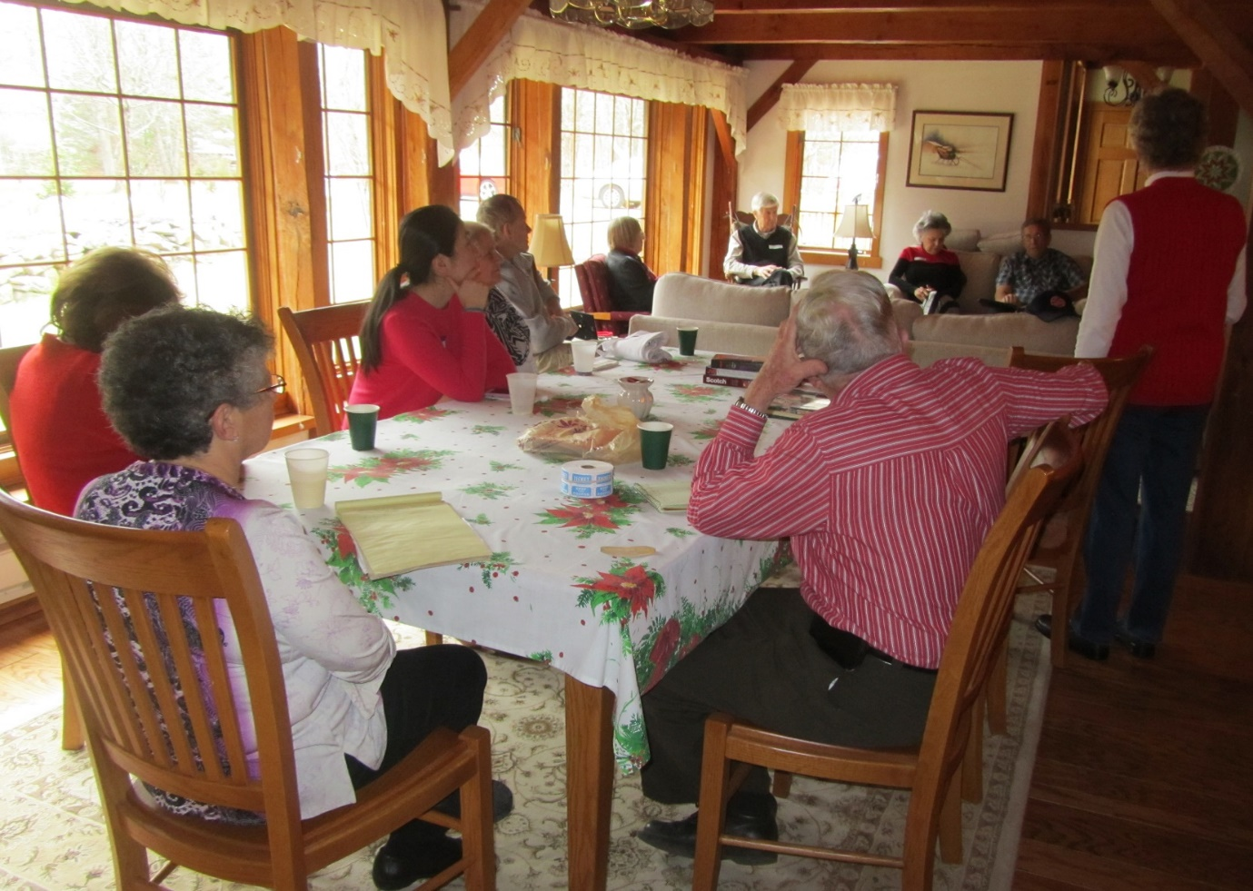
Frenzy Begins After President Message:
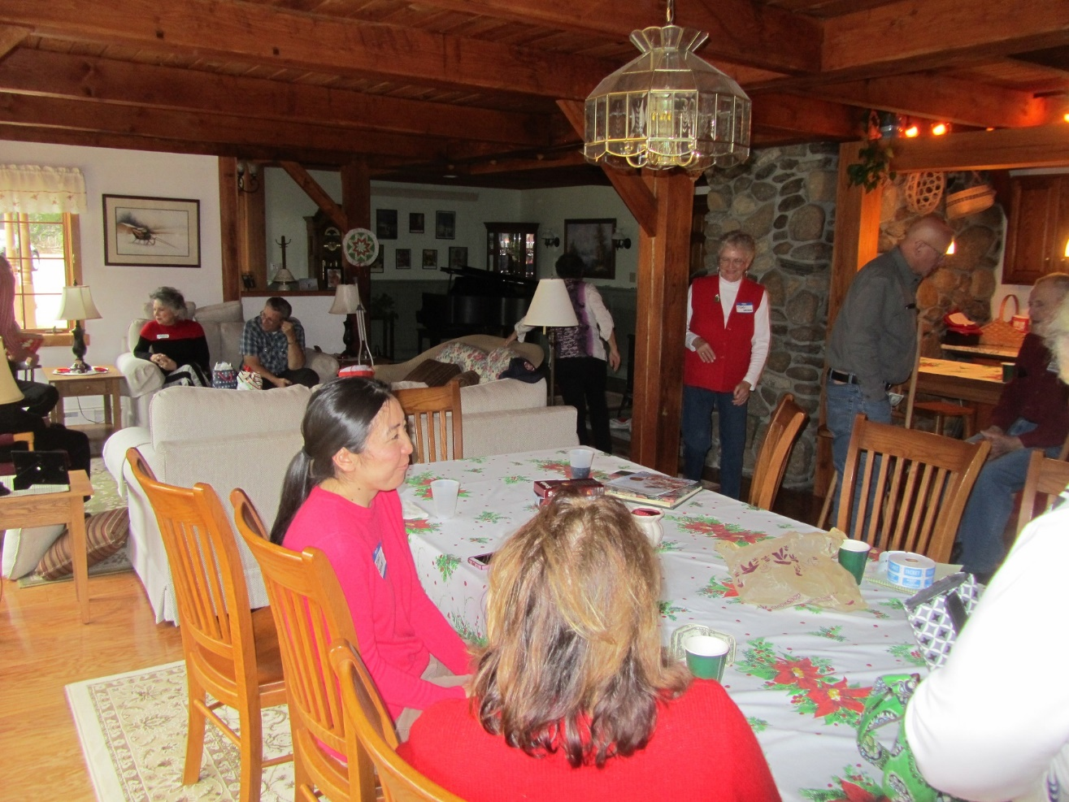
One Happy Camper Hides With Gift Out Of Sight:
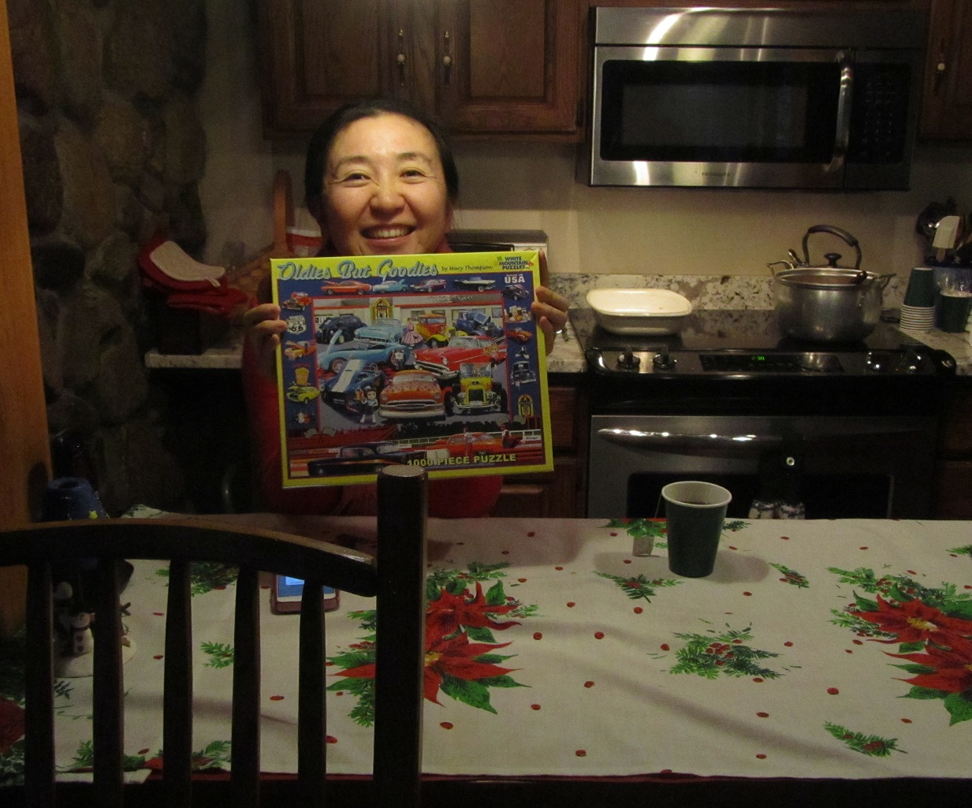
Gift Analysis Continues Deep Into The Opening Progress:
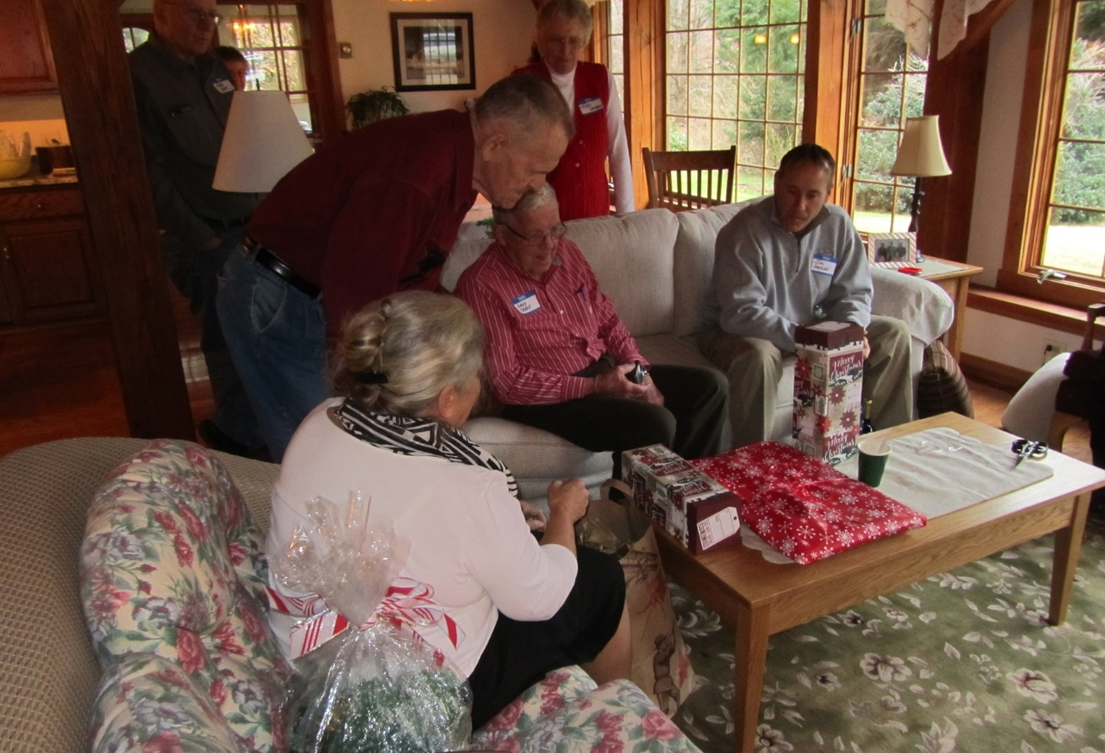
Room Starts Jumping As The Last Of The Gift Swapping Nears:
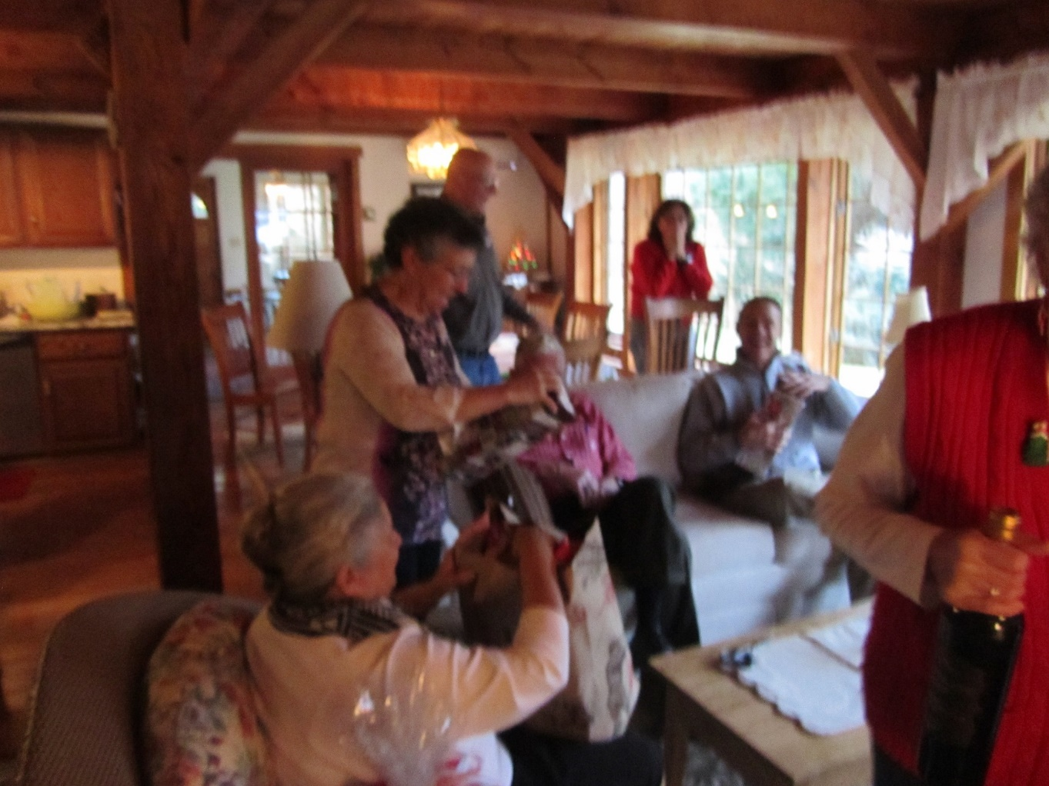
A Gift Mystery Is Solved!!:
