Hydraulic Throw-out Bearing Retrofit
Part 1 - Overview:
Providing this info after only a few months of care free test driving.
Using current day hydraulic throw-out bearing on the vintage Mopars provides:
- Reduced clutch pedal activation force (great for your left knee in stop & go traffic)
- Eliminates commonly occurring stock “z” bar clutch linkage failures
- Provides added under hood room and access
Installation info shown is on a 65 Dart with 225 Slant six with 4 speed transmission. The 4 speed is a late model 70’s overdrive. The info provided could be applied to multiple engine and transmissions with some adjustments.
The big picture…………
Engine Block to Transmission:
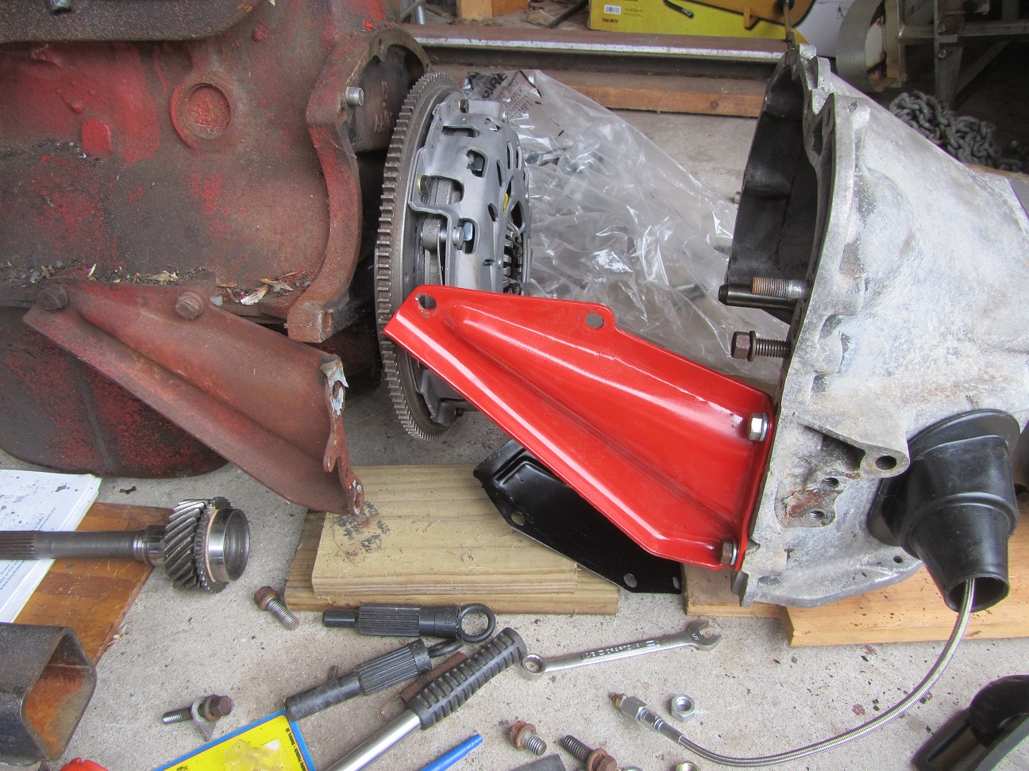

Hydraulic Throw-out Bearing on Transmission:
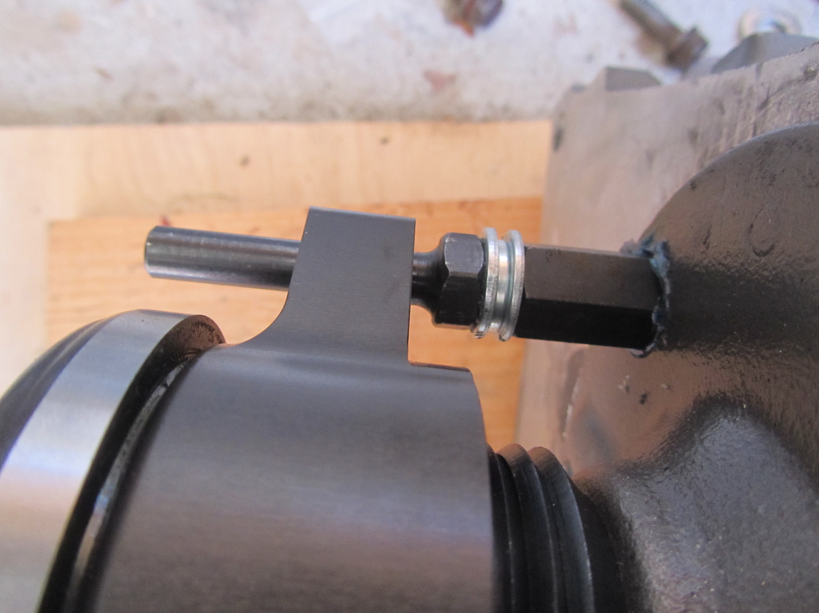
Master Cylinder to Clutch Pedal:
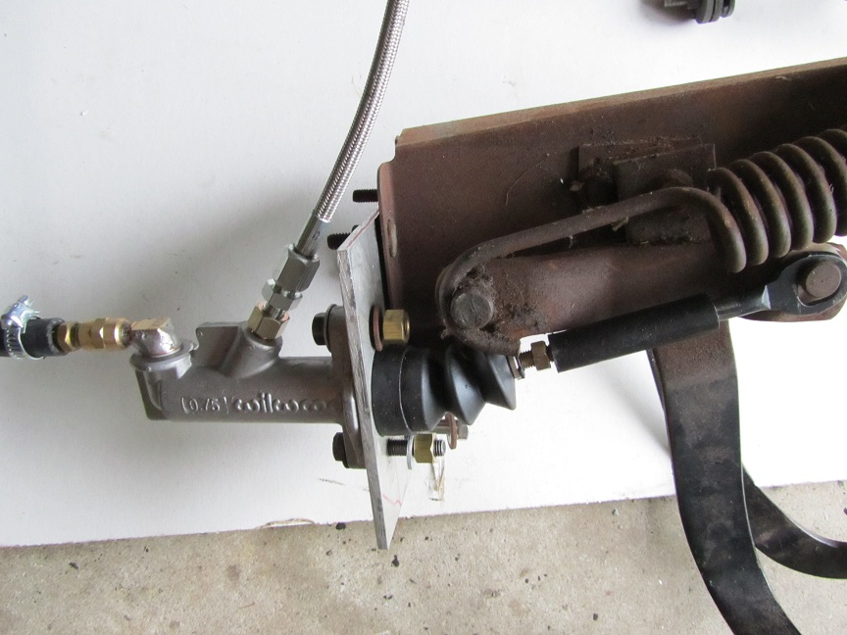
Major components for the install included:
- Wilwood Compact Master Clutch Cylinder
- Wilwood Master Clutch Cylinder Hydraulic Reservoir
- Ford Ranger Diaphragm Clutch Pressure Plate
- Ram Industries Hydraulic Throw-out Bearing
- Hydraulic Lines
- B & B 9 ¹/₈ Clutch Disc
- Transmission 1.375” Collar Adapter
- Re-drilled Stock Flywheel
- Reduced (Smaller Diameter Coils) Clutch Pedal Overtravel Spring
Master Cylinder Info: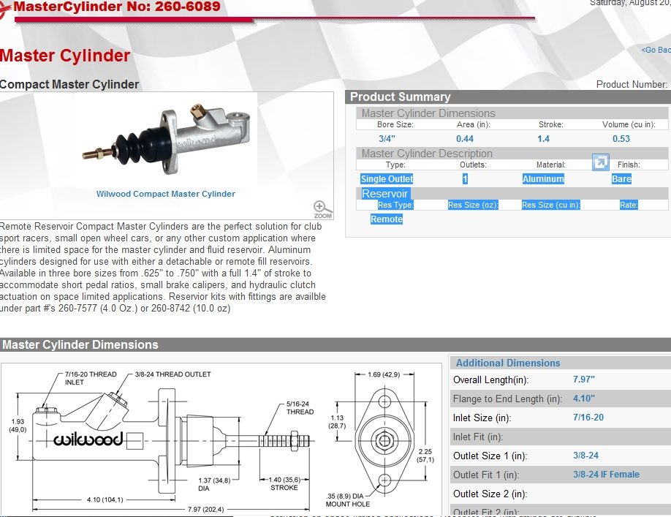
Clutch Pedal Movement at Clutch Master Cylinder Attachment 1.125”
Maximum Allowed Clutch Master Cylinder Movement 1.4”
Volume of Fluid Displaced By Clutch Master Cylinder (in³) .49
Master Cylinder Reservoir Wilwood 260-7577:
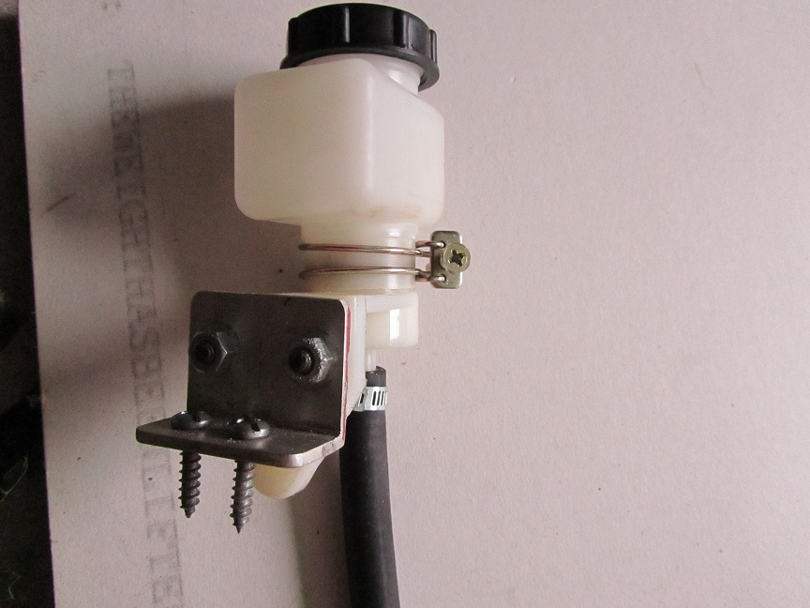
99 Ford Ranger 3.0L 9 1/8 Diaphragm Pressure Plate:
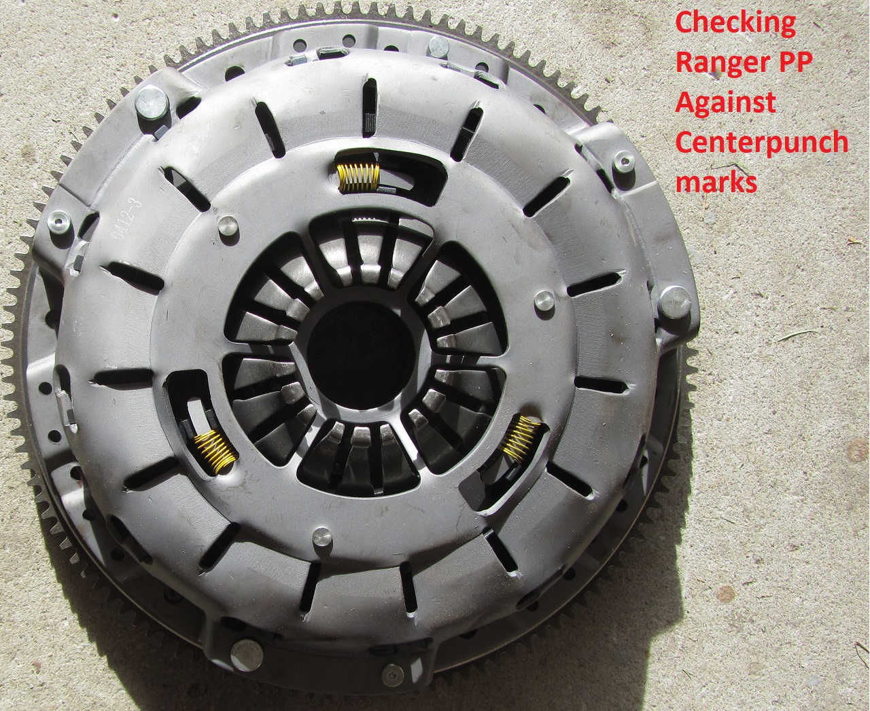
Ram 78125HD Hydraulic Throw-out Bearing:
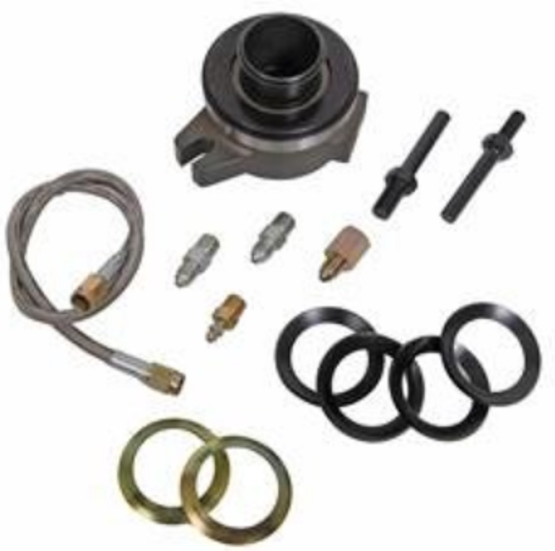
Video
https://www.youtube.com/watch?time_continue=94&v=qrF0BBgSv4Y
Instructions
https://ramclutches.com/sites/ramclutches.com/files/attachments/form_b78125_78125_bearing.pdf

Hydraulic Lines (-3AN) 48” long :
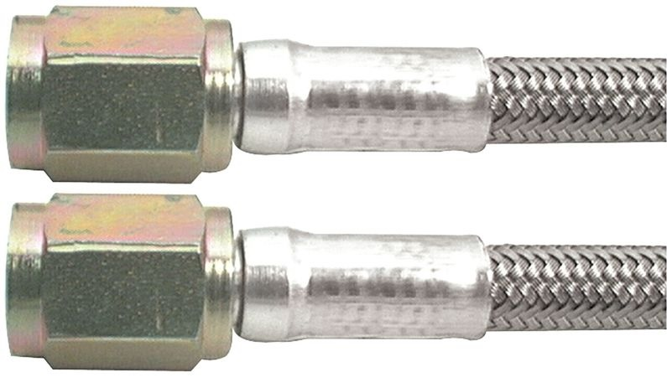
Re-drilled Stock Flywheel:
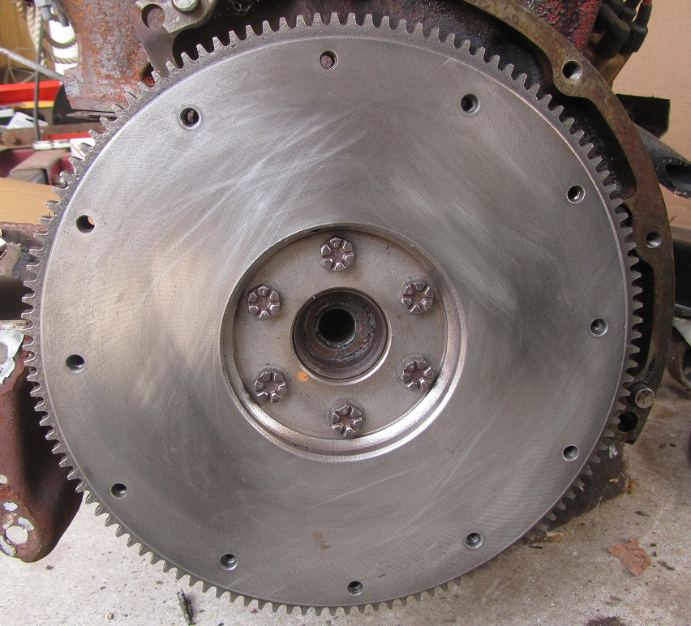
Reduced Pedal Effort also = to Clutch Pedal Overtravel Spring Allowed Change With Hydraulics:
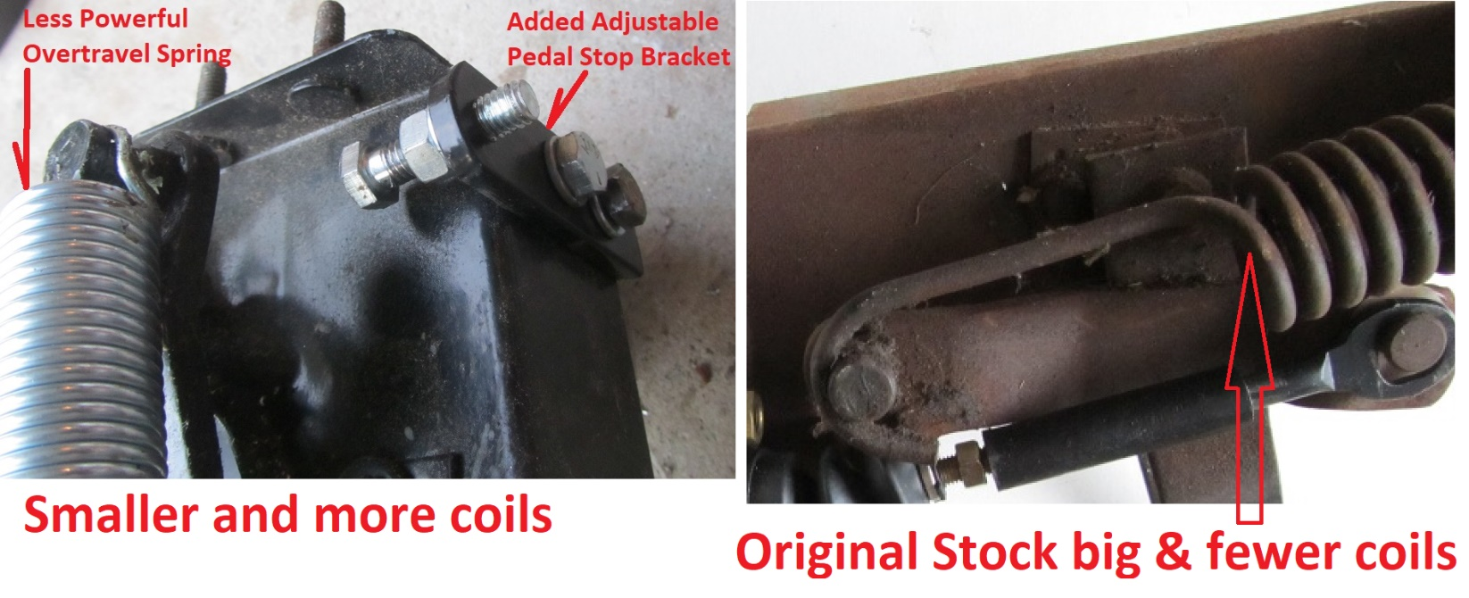
Part 2 (details) to follow.

