Colonial Region October 2017 Event was in Sutton, Ma. at Waters Farm where the Plymouths and Dodges gathered among everything from a 1915 Runabout to a 2017 Hot Challenger with all the go fast toys……….1 century of vehicles in every category were scattered across the field. Bruce and Judi N. participated in setting up the event and managed things while we looked over the show in progress. How they picked another great day for a meet with cool temperature, overcast sky (rather than baking sun), and another rain free day is a mystery.
The fields featured Farm type activities as well as demonstrations and multi-vehicle show in an almost circus atmosphere. Activities ranged from tractor pulls to making shingles. Children’s play area let any parents have a brief respite. Firemen displayed skills at cutting roofs off cars and handily ripping doors off cars rapidly. The Blacksmith building displayed the tools of the trade. Loggers demonstrated wood splitting skills while cattle roamed among the participants.
My favorite car was the same 1965 Barracuda with 37k miles, small 8, 3 speed columns shift that was at the last event in Millbury in September. Bill Kane proud owner stood close by answering questions about the near perfect condition of the vehicle. The camera snagged a picture of his 65 Cuda alongside a 1915 Ford. Shows what can happen in only 50 years separating the two vehicles!!!:
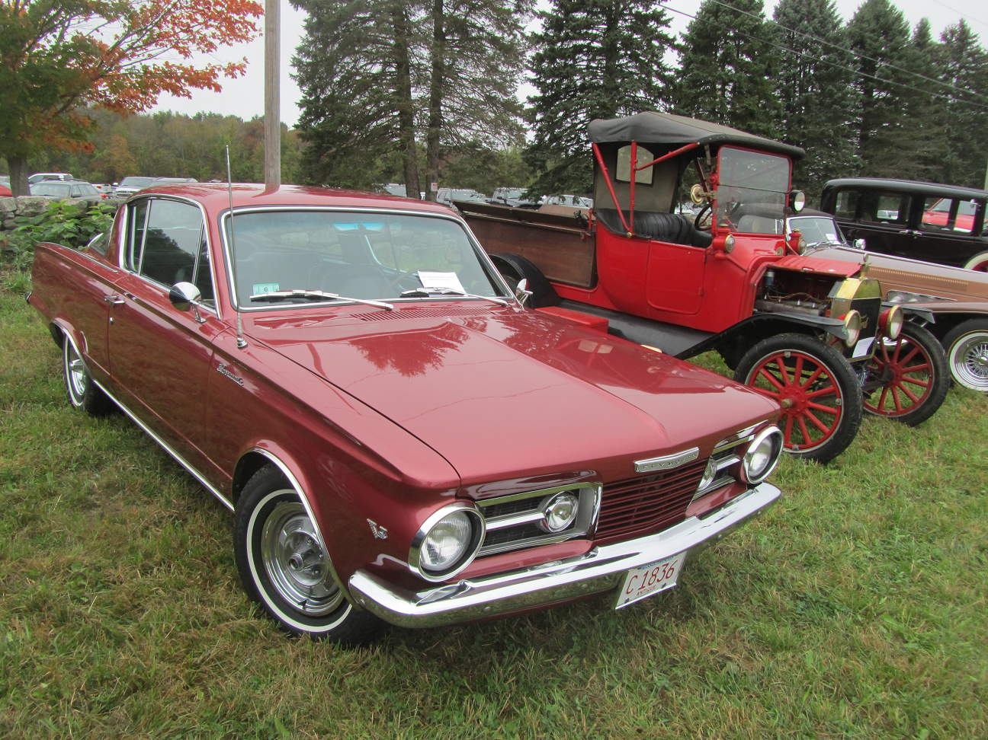
Region member Jerry Adams & his 54 Plymouth were there and it gave me time to do a show and tell on Jerry’s question concerning hard starting that occurred after a quick stop when warm. An upcoming restoration article on the Region website will feature the fix. Jerry & his car jumped into the camera:

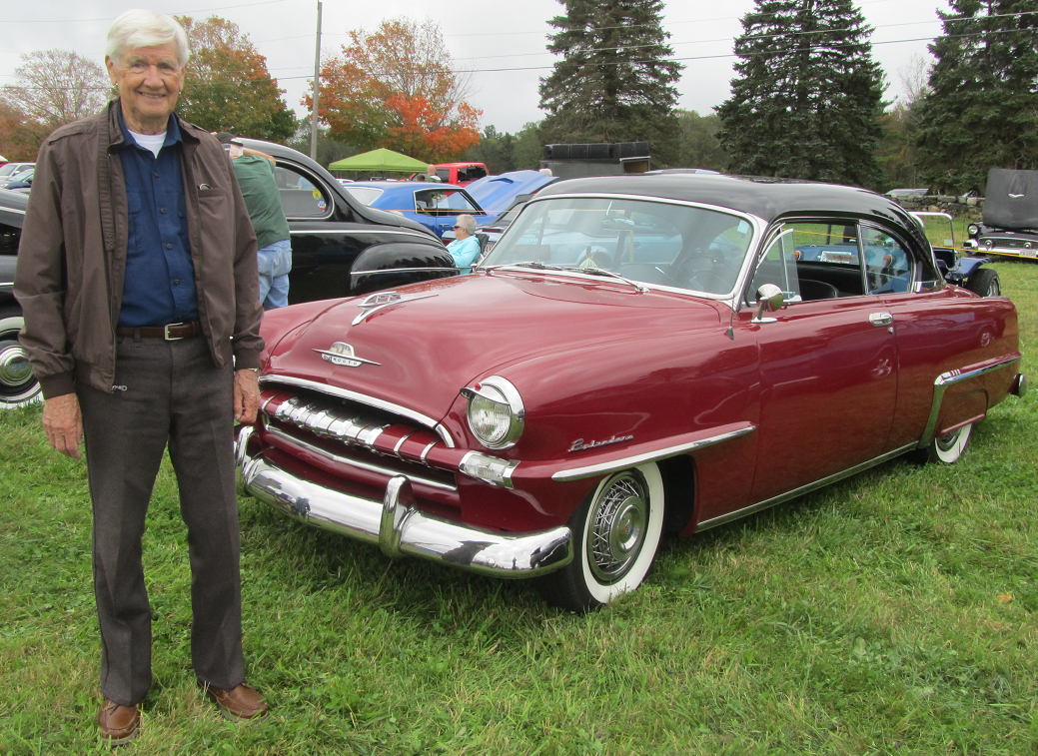
Jerry’s car was in good company surrounded by Auburns, super muscle cars, hot rods, and classic restored cars from every decade. Lots too look at and take in before he even wandered over to the Farm activities.
I’d recommend a hot dog from the Dog Father eating facility; the great taste underscores a 5 star award from me for their cooking skills!!
Besides Region Members Judi & Bruce Nichols & their hot red Challenger there were Region members Jim & Qin Li Dunlea & their restored Plymouth truck watching all the activities and sampling the available cuisine. Their truck was all dressed up for the Fall event:
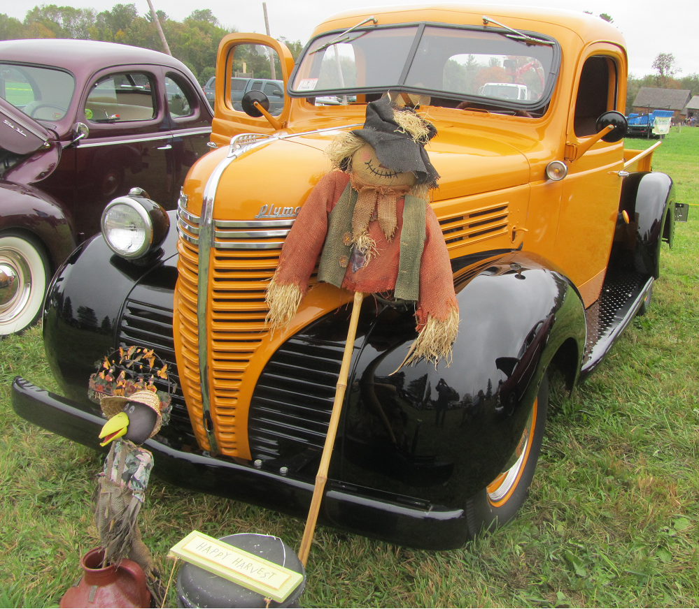

There was no Region Meeting so the above narrative and below pictures should serve to at convey what went on at the October 2017 Meet:
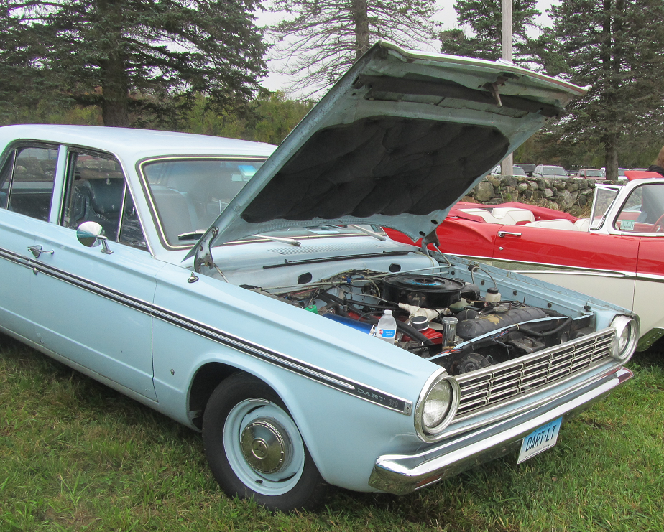
Above is the Don & Jane Palmer 1965 Dart nestled among rare finely restored classics.
Below is one of the tractor pulls:
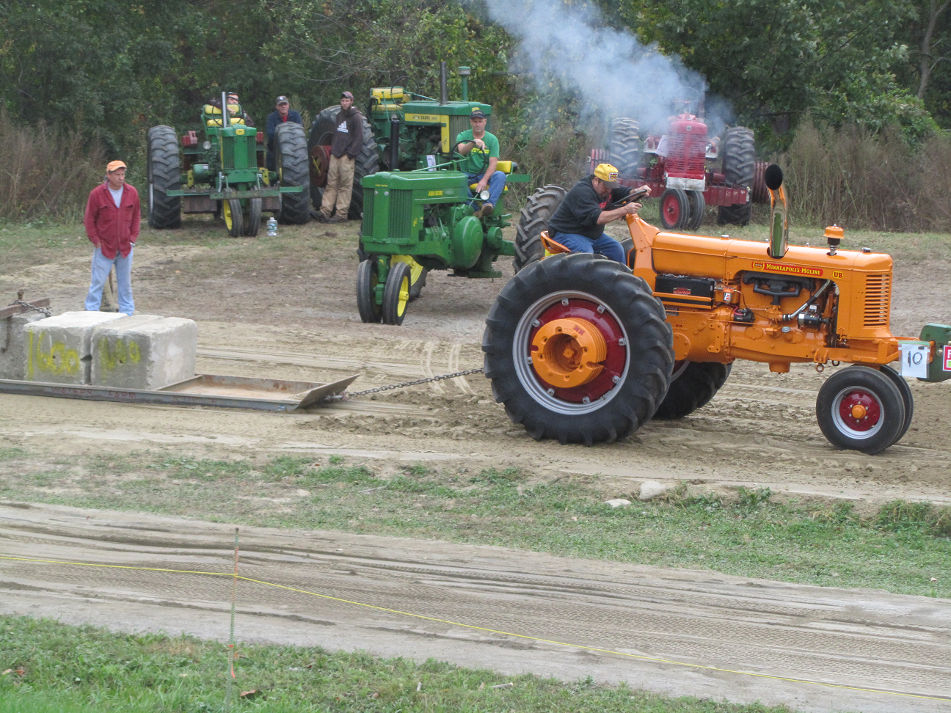
Firemen demonstrated car deconstruction the quick way:
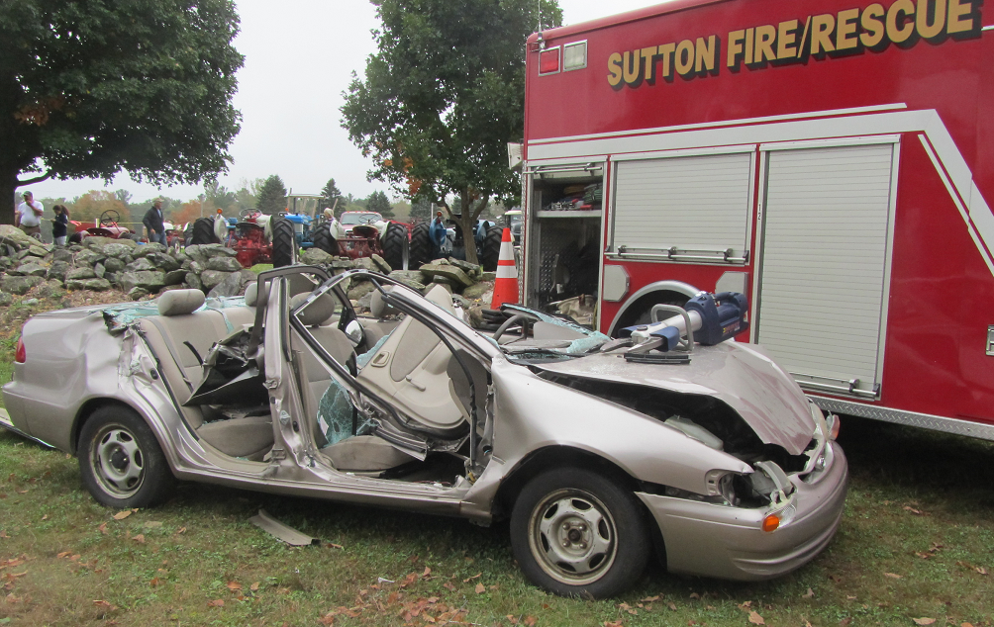
This Valiant sported slant six muscle put to work with all the toys for a quarter mile drag:
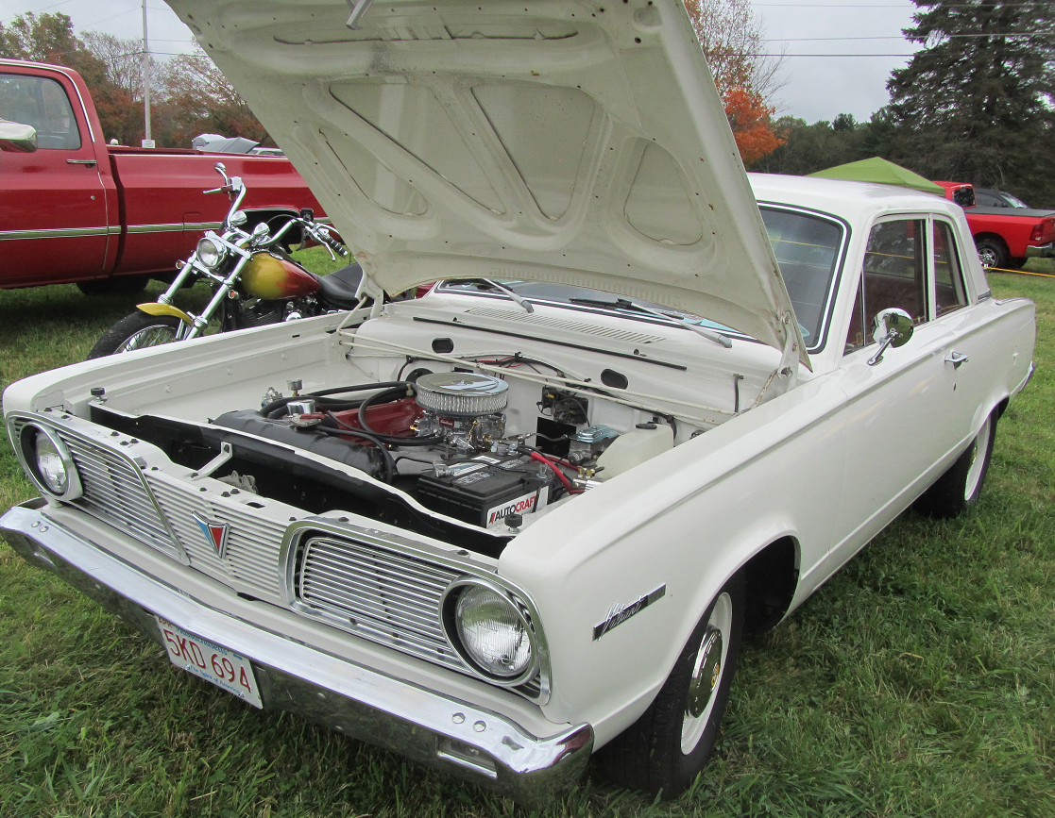
Timber Craftsman At Work:
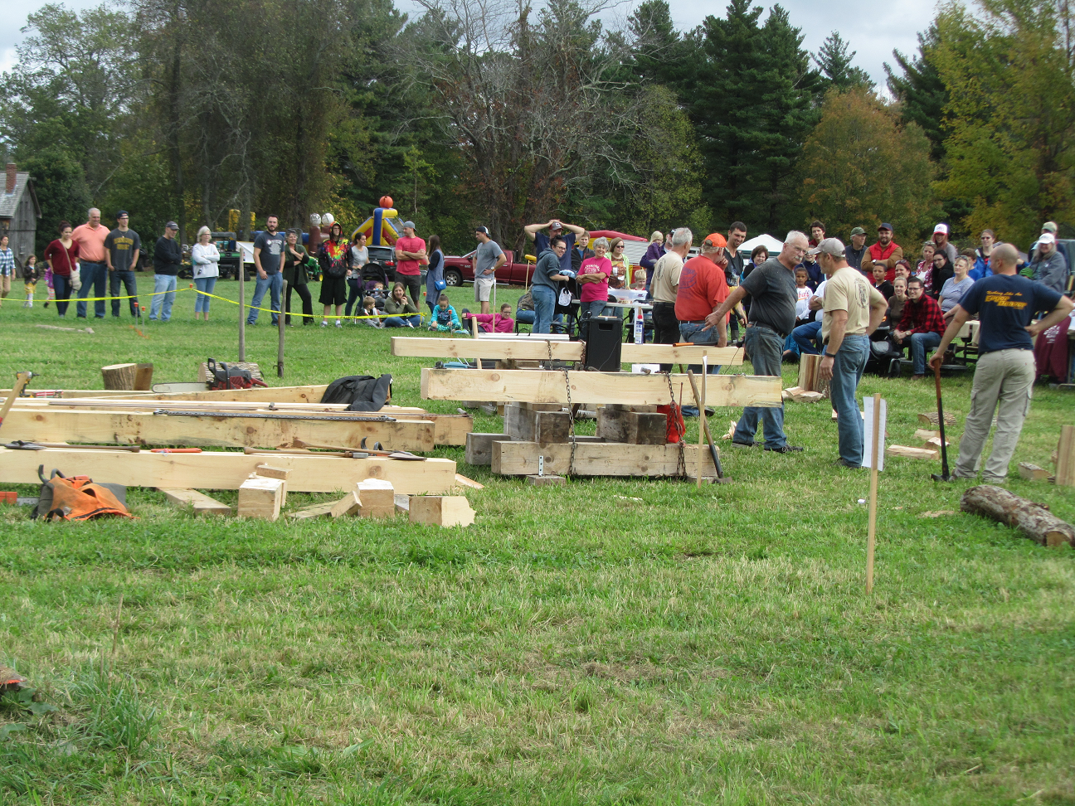
Petting Cattle A Favorite Activity for the little ones:
