March 2017 Sweet Event

Pictures for the March 2017 Sweet Event hosted by the Whitman’s start at the point when the business meeting initiated at the Whitman’s and continue thru the food consumption at the IOKA Maple Sugaring Farm (In Hancock, Ma.) and end with the tour of the IOKA Maple Sugaring Equipment in operation.
The weather was spectacular on a chilly windy day. Luckily the event was sandwiched in between snow events. Who came up with this great timing?!!! Long distant acknowledgement must go to Larry & Lorraine Nuesch who participated in the day’s planned events.
Under the glaze & watch eye of the ever present Don Whitman Fram Clock a few decisions were made, Plymouth 400 progress reviewed, upcoming events formulated, yearly membership status reviewed, and time made for the 50-50 which made the event productive for Region business. See the President’s Message and Secretary Report concerning the details of the decisions reached.
The sun was setting as the last of the members left with their memories & pictures of the day’s events. At least the road conditions were fine for the drive home to round out a perfectly great time.

Fram Clock Awaits Arrival Of Participants

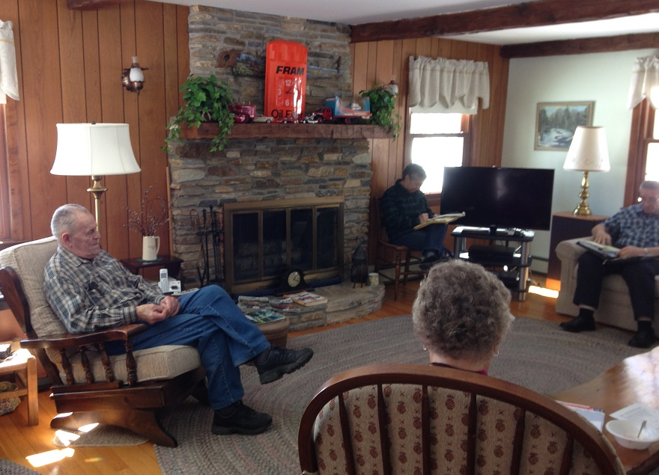

OAKA Maple Sugar Operation’s Front And Center For Incoming Breakfast Guests
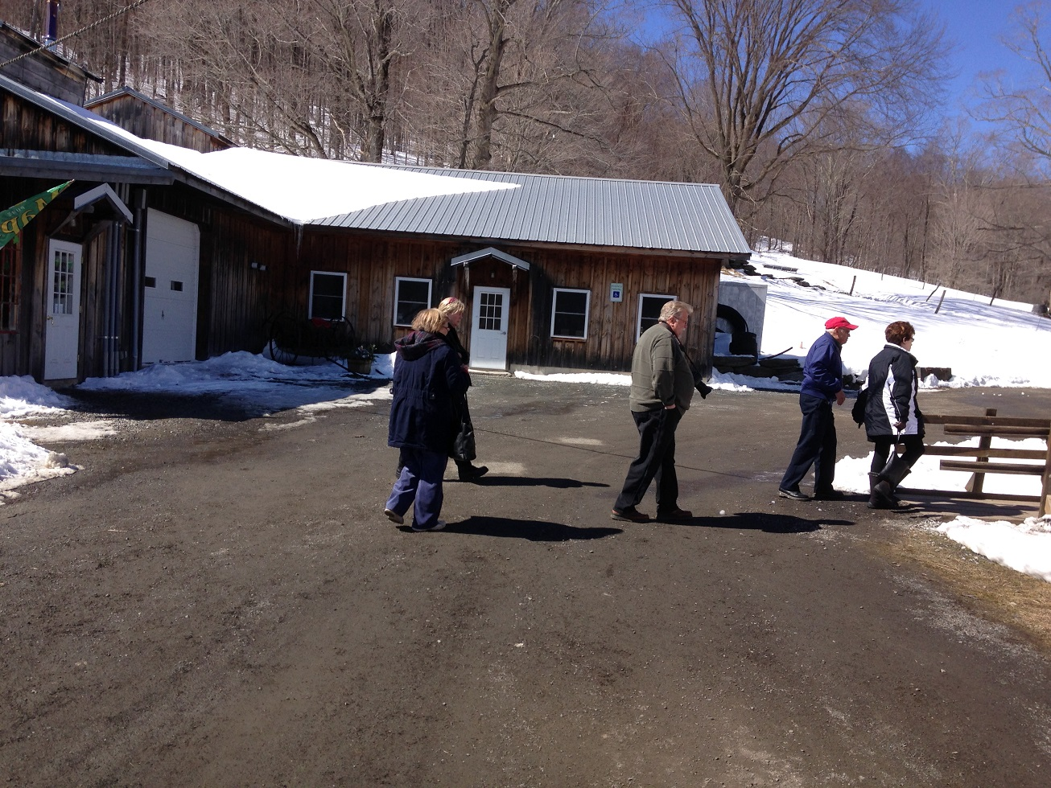
Breakfast At IOKA Serves Up Colonial Region
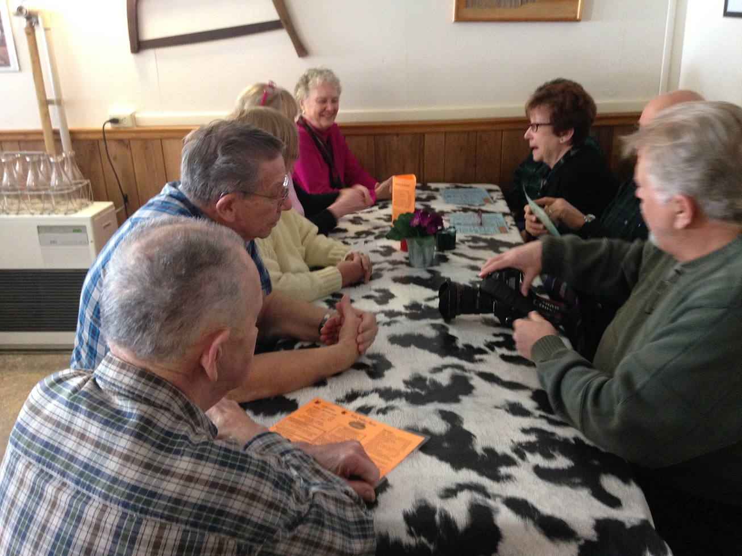
The Breakfast To Order At IOKA Breakfast Inn
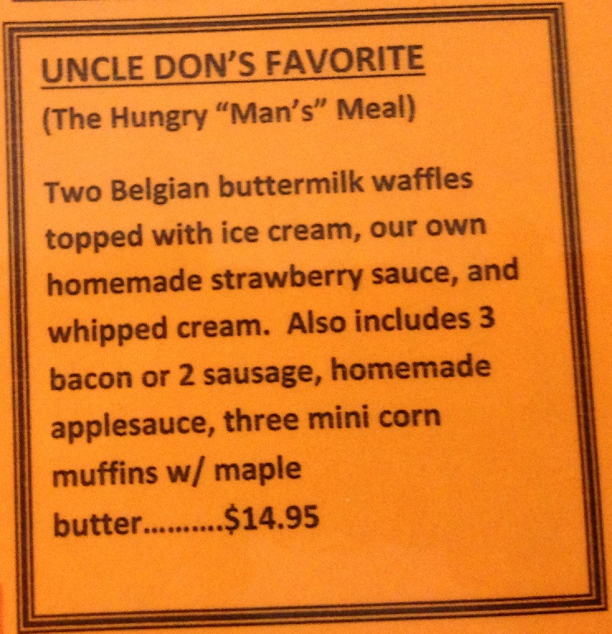
IOKA Sugar House Tour Available To Breakfast Guests
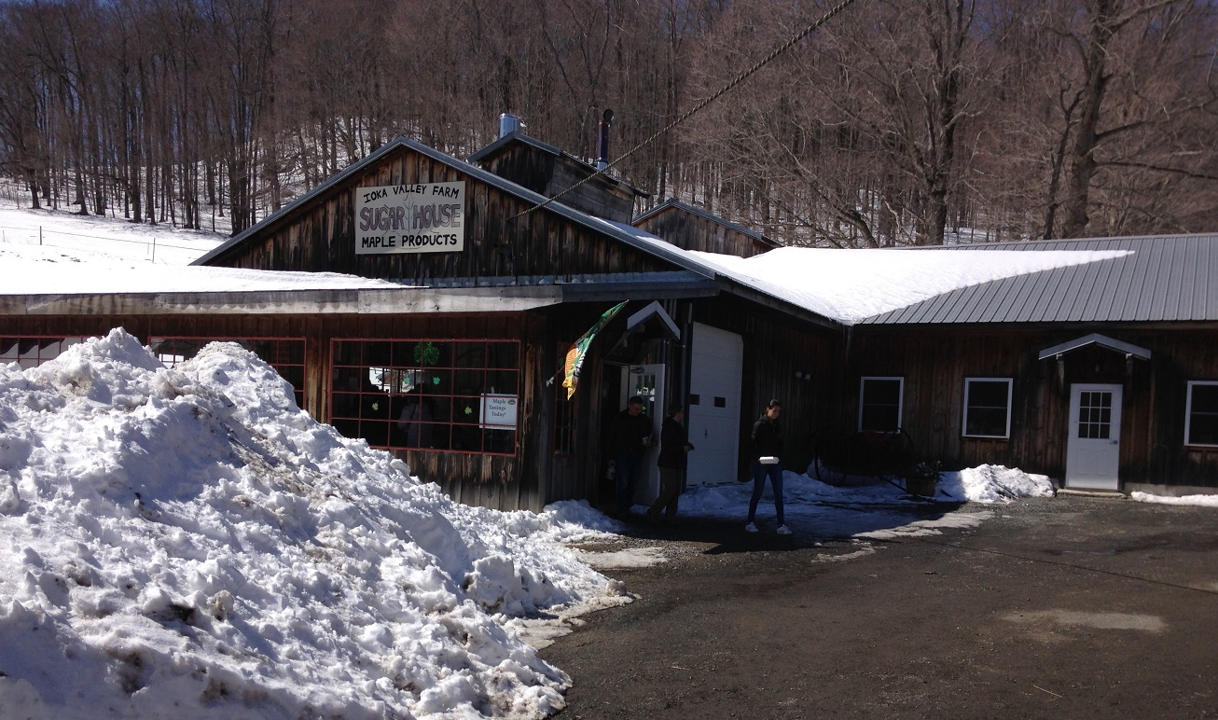
IOKA Maple Sugar Operation Explanation To Colonial Region
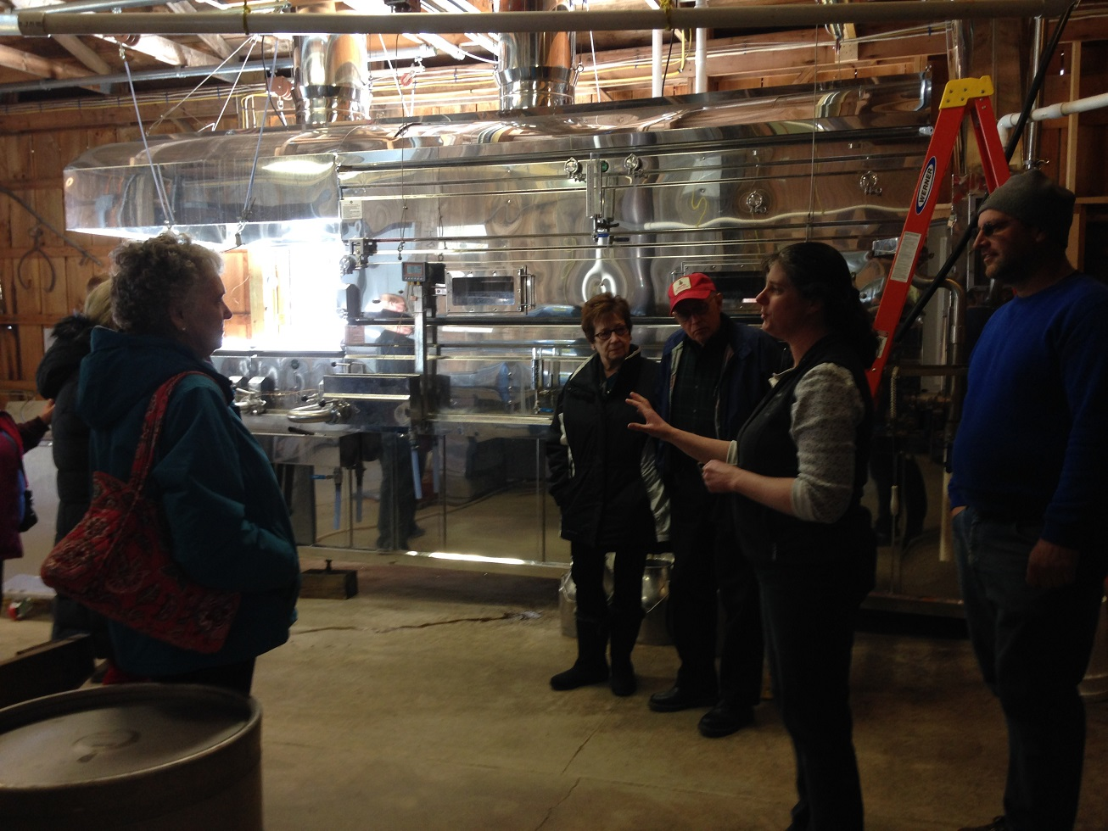
IOKA Maple Sugar Equipment Spellbounds
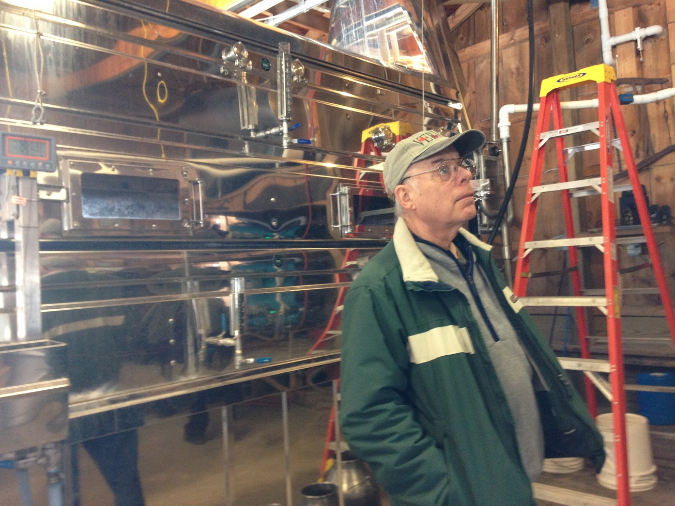
Tour Of Sugarhouse With Super Knowledgeable Guide
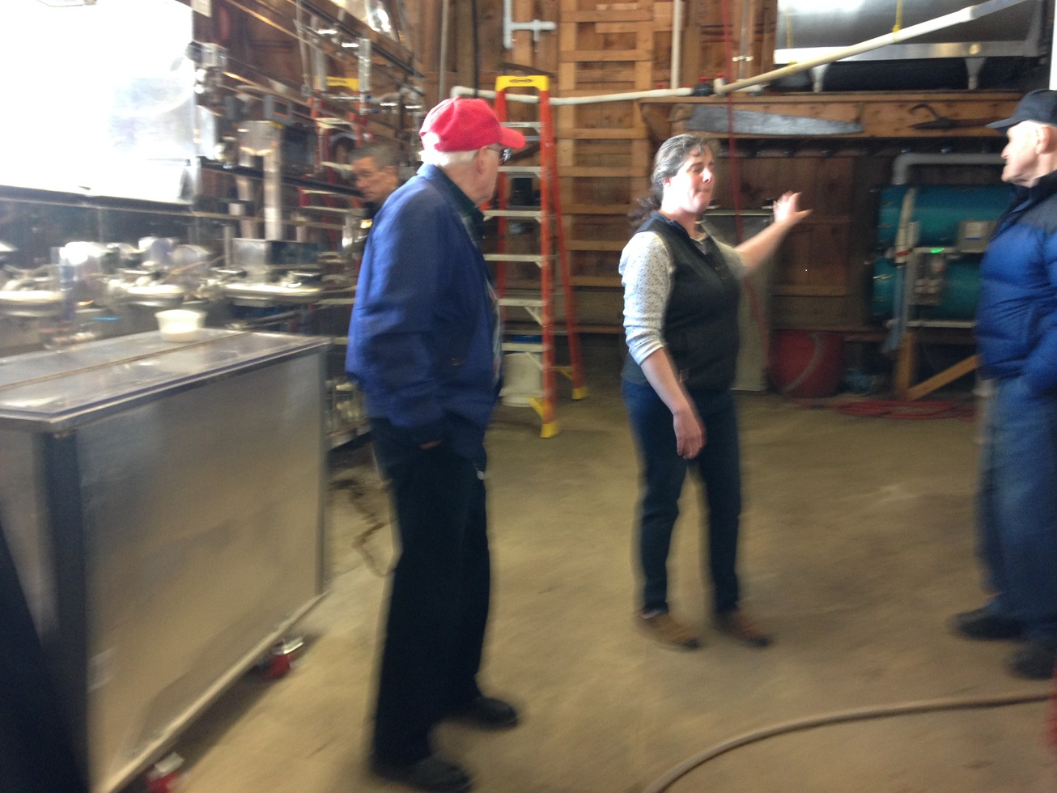

Now wouldn't it be nice to visit IOKA once a year at this time to have one sweet time???!!!

