Colonial Region

WINTER IS OFFICIALLY IN PROGRESS. In Hancock, the first big storm of the season arrived at the exact time predicted in the Farmer’s Almanac. We received 18” of snow on November 20th. The next big storm predicted is a blizzard around mid-February. We’ll see! Don and I are counting the days until spring. I hope everyone made it through the holidays happy & well. Did anyone receive a Plymouth for a gift?

OUR ANNUAL DECEMBER EVENT KICKED OFF AT THE PALMER”S. Thanks again to the Palmer’s, our Christmas meeting was perfect, as usual. We had a good group, great food, and a fun grab bag. The short meeting was only to catch up on business and announcements. We put off scheduling the 2017 meetings until the upcoming annual business meeting.
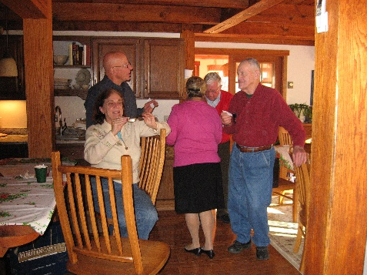

Some annual dues were collected and they are now due for this year unless you are already paid up. Please mail your $15 to Judi Nichols, 33 Beach St., Millbury, Mass. 01527 2017 promises to be interesting. Some of us hope 2017 is even better than 2016. Please think about hosting a region meeting. Nothing really complicated, but something to do is nice, or even afternoon dessert and a meeting. Maybe you have something interesting in your garage or nearby.
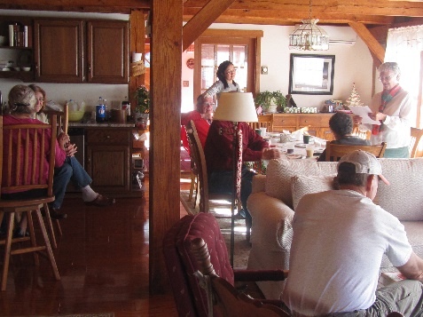

Reviewed at the meeting was the new process used by the Colonial Region for the region news. A news summary sheet is emailed & posted on the website which gives a listing and links to all pertinent news related materials developed during the timeframe covering past and future events, event coverage photos, recent region news related items, and administrative shout outs.

Sample News Summary

This summary is sent out by email with attachments and a printing team puts together a packet of selected pertinent documents and mails to those without email and/or internet capability.

This makes the news fast, up to date, comprehensive, and available on a significant array of media.

Bottom line…. instead of seeing only a few select photos…. you can see them all and select your favorites!

OUR UPCOMING EVENT is the next meeting (our annual dinner and business meeting) on Sunday Feb 26. We pushed it past the holiday weekend because of the busy restaurant. Our surprise choice this February is the Salem Cross Inn at 260 West Main St. in West Brookfield, Mass. on Route 9. 508-867-2345. Meet there at noon. Dinner served at 1pm.

