Instructions to Fit FD117 Extended Tipped Rotor Into Slant 6 Distributor Cap
Suggested steps are for the situation where no jig is available. Goal is to fit fabricated wide width extended FD117 tip rotor with tip to cap terminal gap near .020 “ in a standard cap. Rotor is MO3000 with the FD117 tip installed 1/64 beyond the MO3000 normal tip location.
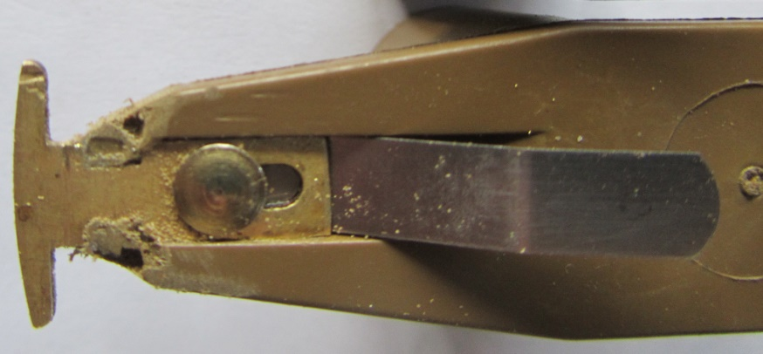
Tools referenced include: spare distributor, dremel tool with 1.5 cutoff wheel, and magic marker type pen. Suggest doing the work in a very quiet room.
Overall procedure involves: determining which cap terminal is the most eccentric (or closest to the rotor & marking that terminal, labeling the terminal that is furthest away from the rotor (biggest gap), grinding away excess material on the terminal(s) that hit the rotor, side loading the bottom gear to determine what terminals are then hit by the rotor, and finally grinding those terminals until the rotor hits no terminals when the distributor gear is side loaded. Avoid using severely worn distributors that have significant bushing wear.
Cap Machining Steps:
- Remove ignition points or electronic pickup assembly from the distributor plate; insure the distributor shaft rotates smoothly without binding or noticeable drag in any location. Apply lubrication to the bushing area.
- Install Rotor on distributor shaft; mark distributor gear to indicate direction rotor tip is pointed. This marking will be used (once the distributor cap is installed) to determine to which terminal the rotor is pointed.
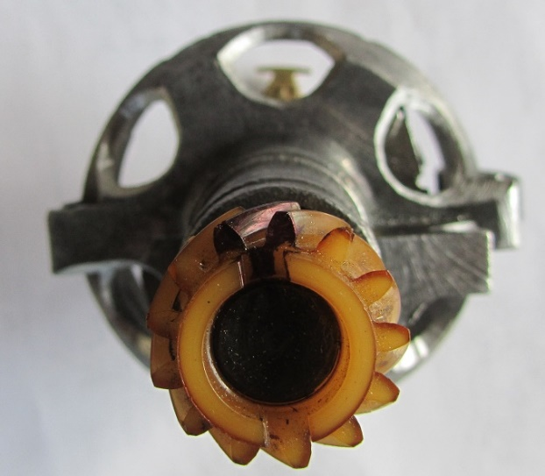
- Install selected distributor cap insuring the cap is oriented as it will be when installed on the engine. Near the vacuum advance the clip must engage the distributor cap notch.

- Rotate distributor gear clockwise until the rotor scratches or strikes a distributor cap terminal. Mark that terminal on the cap with a mark.

- Rotate the rotor in the extreme opposite counterclockwise direction until the rotor scratches or strikes a distributor cap terminal. Mark that terminal on the cap.

- Observe the relationship of the terminals marked……you have the possibility there is:
- only one terminal struck,
- multiple terminals struck, or
- no terminal was struck by the rotor.
Case a) where there is only one terminal involved has that terminal as the most eccentric terminal on the cap that falls closest to the rotor……label it ET for Eccentric Tight gap. Other terminals close to this terminal will also be extremely close to hitting the rotor.
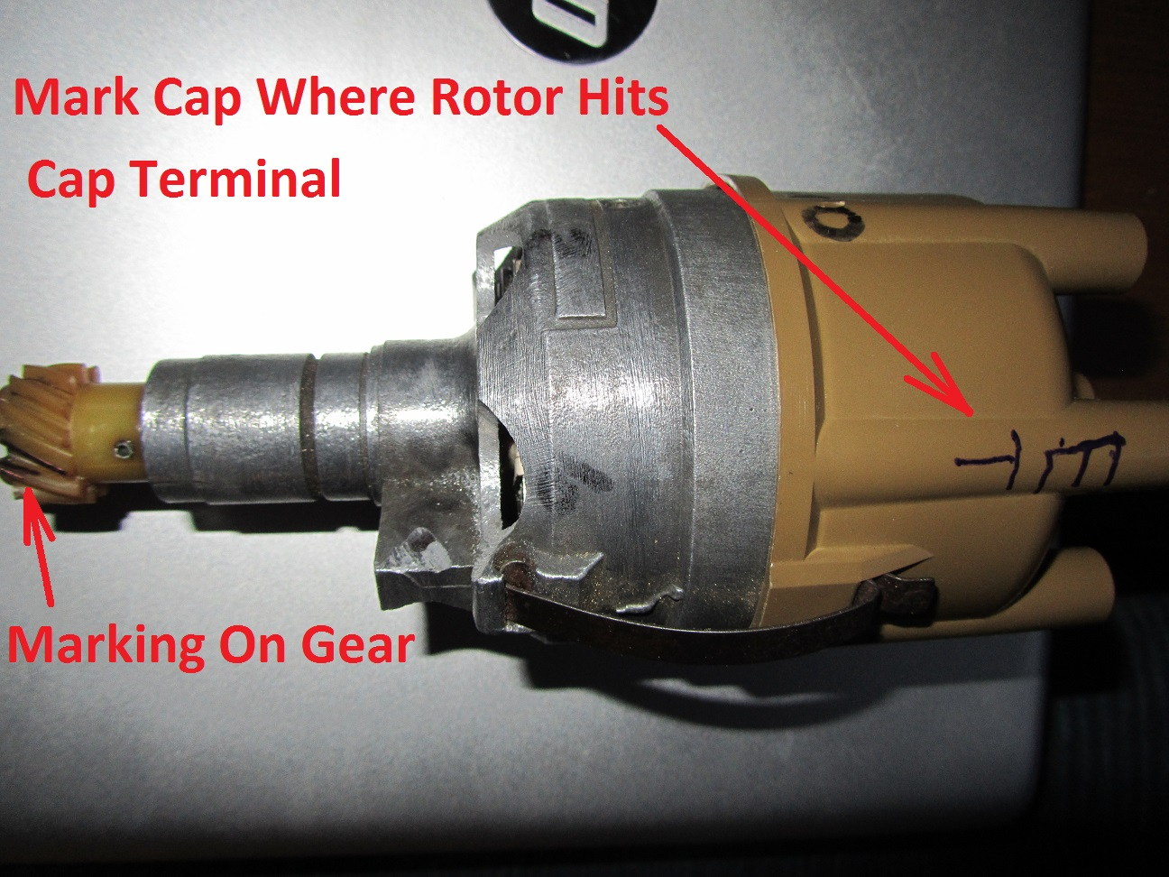
Label the opposite terminal on the cap (180 degrees away) as EL for Eccentric Large gap. The example shown had the tight terminal to the rotor at #6 so the large gap terminal is #1 due to the eccentricity of the rotor center relative to the cap center being offset toward #6. This eccentricity or offset varies with the cap so your cap is likely to be offset toward a different terminal.
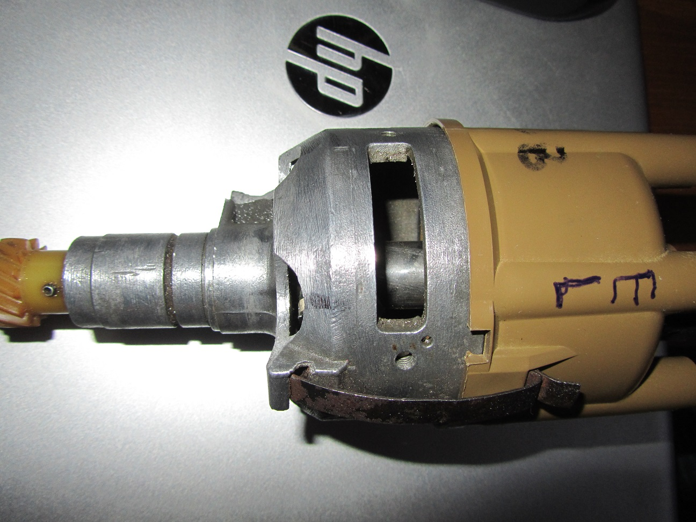

Case b) where multiple terminals are being hit by the rotor require the ET to be marked halfway between the terminals being hit by the rotor.

Case c) where no terminals are being struck requires that the above testing be performed with a side load applied to the distributor gear to find a terminal being hit by the rotor. The side load is applied where the gear is marked and the gear is rotated until a terminal is hit.

- Once the ET location is determined remove the distributor cap and machine a few thousands off the ET terminal using the Dremel held on a slight angle.

The angle is used to avoid hitting the distributor cap center electrode with the cut off wheel accidently.
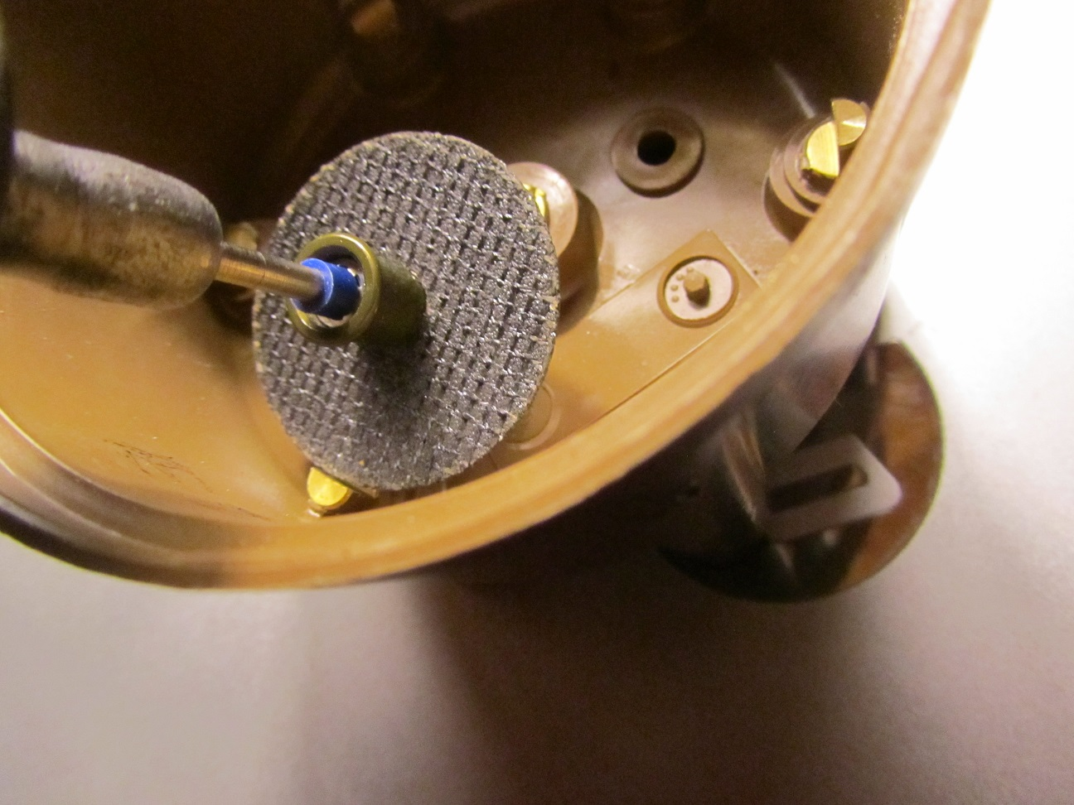

- Replace cap on distributor and rotate rotor to determine if the rotor clears the terminal. If the rotor hits the ET terminal again remove the cap and grind some more off that ET terminal.

- Once the rotor is clearing all terminals it is time to apply a side load to the distributor gear by applying a load at the location of the marking on the gear. Align the rotor with a terminal by watching the distributor gear marking. Then press on the gear and determine if the rotor is pressing against the terminal by trying a small rotation of the gear. Any terminals that do have a hit or scrapping with the rotor will require some of the terminal to be removed by the Dremel wheel.

Terminals closest to the ET terminal are likely to have the rotor hit the terminal when a gear side load is applied. Terminals near the EL terminal are unlikely to require any machining. Once the rotor clears all terminals with the side load applied to the gear your effort at getting the cap’s terminal centerline closer to matching the rotor centerline is completed as well as the goal of a .020 rotor tip to terminal cap gap.

