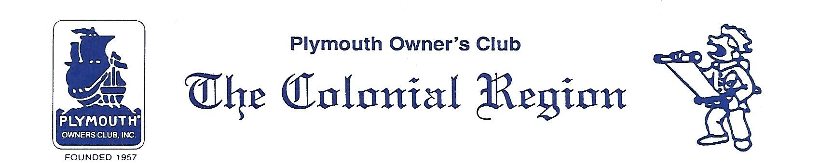
Town Crier News
As Of Jan 14, 2017
This month’s newsletter consists of this Town Crier News lead sheet and the following from the Colonial Region Website www.plymouthcarclub.com :
- Presidents Message Jan 2017
- December 2016 Event Review
- December 2016 Secretary Report
Region Members (without access to the website) are receiving a printout of the above reports along with this Town Crier News summary mailed to their residence.
Region Members (with access to the website) can review each of the above documents online at the above website using the links.
The documents review past event(s), upcoming events, decisions made at the meetings and communications from the officers.
The method of using the website material in the newsletter distribution was reviewed at the December 2016 Christmas Party held at the Palmers. It is also contained in the Presidents Jan 2017 message. You may comment at the website & share your thoughts and ideas about this format.

