Colonial Region

FALL IS OFFICIALLY COME AND GONE but maybe you shouldn’t put that antique Plymouth in storage just yet. It seems the weather can’t make up it’s mind. Don took the ’61 Fury for a short ride mid November and it can still be enjoyed.

OUR OCTOBER EVENT KICKED OFF with 10 members enjoying a tour of the New Bedford Fire Museum. They viewed old fire equipment, old fire engines, and city fire records from 1890. A visitor could try on old uniforms or even slide down the fire pole although no one braved that. Members then drove to the Inner Bay Café’ for a delicious meal. That restaurant is very popular and always busy. Thanks to Bill Rogers for setting up this meeting and Doug Crook for the map and details.

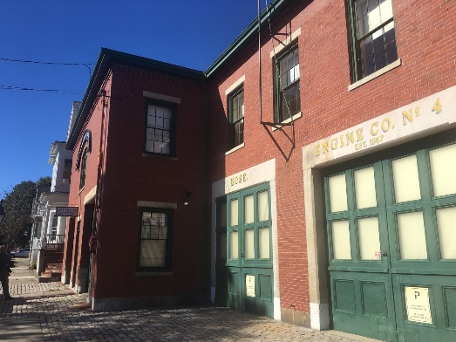

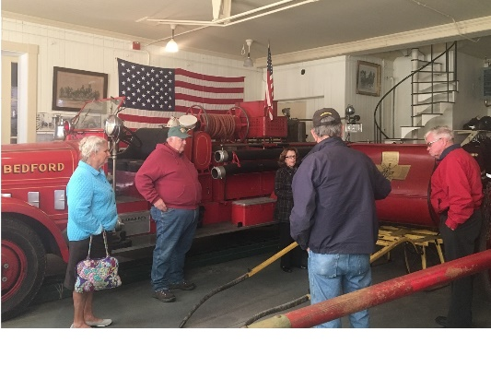
OCTOBER ROUTE 66 TOUR by the Palmer’s in their Dart ended with pictures on our web site at plymouthcarclub.com.

OUR MID NOVEMBER EVENT STARTED with 11 of us enjoying the family style chicken dinner at the Wright’s Chicken Farm Restaurant in Harrisville, RI. Thanks to Vince Ruops for arranging this great meal. Bruce Nichols was determined to go, even though he had knee replacement surgery on the 8th. He didn’t make it.
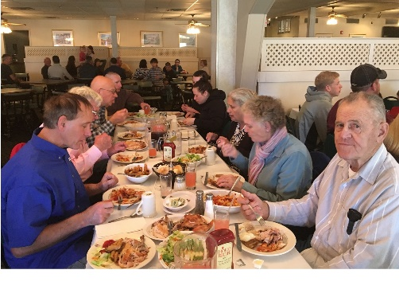
The holidays are upon us and that means our annual Christmas party meeting at the Palmer’s in Tolland, CT. It is always the first Sunday in December = the 4th this year.

