Colonial Region

**SPRING HAS SPRUNG IN N.E.** with a dry warm April and 2 weeks of warm May weather to date. Out came antiques in numbers on the streets.

The Colonial Region May meeting fell on one of those beautiful days with 70’s at the Thompson Speedway in Ct. It reminded us of the day we went around the Indy 500 track at a National Meet.

This time The Plymouths made 3 laps around the track with Ramblers stretched out around the turns since the meet was arranged as a combined Rambler & Plymouth event.

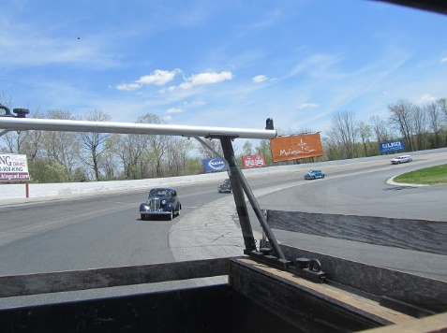

Photo shoots occurred on the track.

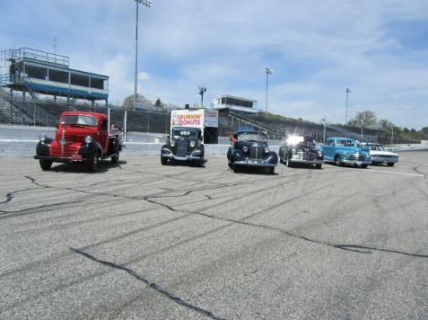

Thanks to planning by the Nichols team the event came off wonderfully for all involved. Complete coverage of the meet can be found at the Colonial Region website: plymouthcarclub.org

Look for the posting:

**May 2016 Region Report**

There was no Colonial Region discussion or formal meeting minutes since we were having too much fun although there was some discussion at the clubhouse during lunch about the upcoming June meeting.

**NEXT MEETING:** Sunday, June 12, 2016 at the Crook’s home in Little Compton, RI.at 11:30 AM. Lunch needs a head count so call them if you are coming.

**UP COMING MEETINGS** include July 17, we have planned to have a picnic at the Colt State Park in Bristol, RI. August 21 is a tentatively planned event for a tour of the theater in Millbury, MA. Our weekend at the Cape will be in September. On October 16 there are tentative plans to visit Plymouth, Mass.

***- Don and Jane Palmer***