Colonial Region
It isn’t spring yet but the trees are growing fat buds. Ioka Valley Farm at 3475 Rte 43 In Hancock, Ma. has already boiled over 100 gals of maple syrup and the daffodils are up. 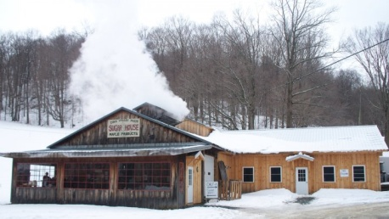 Soon we will be uncovering our antiques for another year of cruising. Some have been out already. There are several “rat”rods in this area and they don’t worry about the salt on the roads.
The February meeting at the Nichols’s home was well attended with several guests. Doug Crook presided over the meeting. He welcomed Brian Siplo and his 1951 Cranbrook. Brian Siplo joined while there, so we welcome him into our club. The Secretary's Report was accepted. Judi Nichols distributed the annual Treasurer's Report for all to view and it was accepted. She gave a reminder that those who have not paid their dues should send them to her.
Tom Dorward wanted the club members to know that the Chrysler Club will be holding its National Meet in Maine in September.
We have a need for a Club Historian. Bruce volunteered. It was noted that Judy Whitman has the original charter and that Betty Kibbe has the club photos which will need to be given to Bruce. John Gilman had heart surgery so a card was passed around for all to sign.
Don Palmer discussed the new things on the website: regional report sent to Lanny every other month, member car pictures, and selling parts/cars. The most recent pictures added to the website included John Gilman's 31:
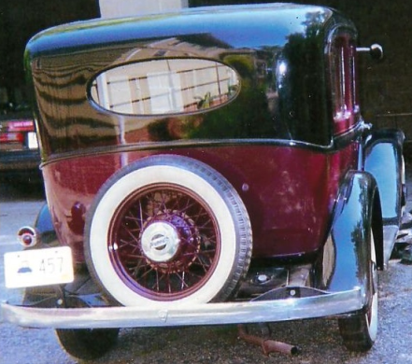
The website can be viewed at Plymouthcarclub.com. You may contact Don if you have items to put on the site. He is willing to help anyone having trouble navigating the web site. We worked on the meeting schedule. Thanks go to the Nichols for hosting the Feb. meeting.

Next Meeting: Sunday, March 20, 2016 at the Whitman home in Hancock, Mass. 3326 Rte 43, near Jiminy Peak Ski Area (Approx. 5 miles from Rte 22 in NY.) Lunch will be at 1:00 at Ioka Valley Farm for pancakes, waffles, etc. followed by our meeting back at the Whitman’s. We need reservations at the farm, so please let the Whitmans know if you are coming by March 16 ( 413-738-5322 or gvebigman@gmail.com). Cost is $5 each for members.

Up Coming Meetings: April is still open. If no one is available to organize a meeting for April, we will skip that month, On Saturday, May 14 we will go to the Thompson Speedway in Thompson, CT meeting at 10:00 at guest services.
The May event at the Thompson Speedway sounds exciting. Bruce has been working hard to organize the event. Driving your old car on the track is very enticing.
The Crooks will host the June 19 meeting in Little Compton, RI. On July 17, we have planned to have a picnic at the Colt State Park in Bristol, RI. August 21 is a tentatively planned event for a tour of the theater in Millbury, MA. Our weekend at the Cape will be in September. On October 16 there are tentative plans to visit Plymouth.
- Don and Jane Palmer

