Colonial Town Crier April 2024
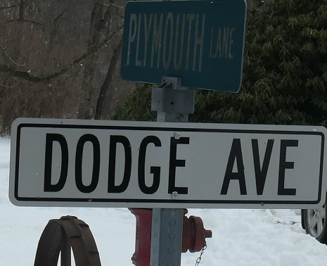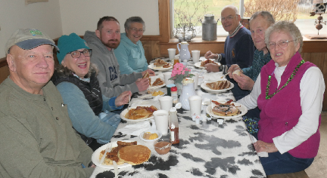
Mar 2024 Meet Kicks Off When Region Members Meet Up At The Corner Of Dodge Ave. & Plymouth Lane And Ends With Eats & Treats at the Sugar Shack With Maple Trees Hard At Work To Keep Up With Demand PRESIDENT’S MESSAGE
I’ll bet everyone is busy with spring chores and going to all those activities postponed until good weather.
This is a good time to get ready for our club celebration of 50yrs as an Official Colonial Region Club.
The Banquet is on SUNDAY APRIL 21 at the PUBLICK HOUSE in STURBRIDGE, MASS. at 11:30am.
RESERVATIONS are REQUIRED BY APRIL 14 **. COST is $25/person, paid in advance. tax and tip included.
Dinner choices are: Yankee Pot Roast, Roast Turkey, or Chicken Pot Pie. Choice needed with reservation.
MAKE CHECKS out to COLONIAL REGION POC and send to Jane Palmer, 184 Buff Cap Rd. Tolland, CT 06084.
Info: Publick House address- 277 Main St. also Route 131 Dinner served at noon. Memories, door prizes and more
Questions: Jane 860-875-0022 , 184palmer@comcast.net.

7 members made the trip to IOKA Valley Farm on March 17th for the annual Maple Goodie Brunch. We enjoyed great service, plenty of food and wonderfully inspired food from maple lemonade to maple ice cream pie and everything that goes with fresh maple syrup. Members even took home maple hot sauce. Ever had a ham sandwich in French toast?
At our short meeting we discussed upcoming events. We decided to use the HVFD car show on Saturday May 11 as our May gathering. The show is at IOKA Valley Farm on Route 43 in Hancock and benefits the Hancock Volunteer Fire Dept and Cancer Society. Don will post details on the club web site. It goes from 10-2, we can park together with the club sign and there will be food available. Rain date is Sunday.
Jane is looking for something different for later in the year. If someone would like to arrange a short road trip, museum visit, luncheon, or car display, please contact Jane Palmer.
FYI, I heard one of our members wants to sell his Plymouth suburban. Hope you check the “For Sale” on website.

Judy

Colonial Region website www.plymouthcarclub.com
President-Judy Whitman, PO Box 1086 ,3326 Hancock Rd. Hancock, MA. 01237 (413-738-5322) gvebigman@gmail.com
Secretary-Jane & Don Palmer, 184 Buff Cap Rd., Tolland, CT. 06084 (860-875-0022) 184palmer@comcast.net
Treasurer- Bob Cook, 175 Putnam Hill Rd., Sutton, MA. 01590-1118, (508-865-4111) Cook4111@hotmail.com

