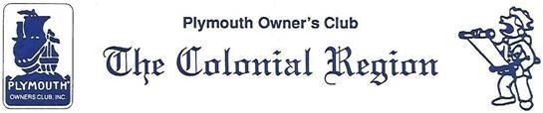
Newsletter - Apr 2021 www.plymouthcarclub.com PRESIDENT NEWS - HAPPY SPRING!!! I am composing this on April Fool’s Day ---- & it is snowing. Mother Nature’s April Fool. Food For Thought …….. Is there anyone out there who would think about being our editor for a newsletter? It takes a bit of computer savvy which I do not possess. If not, how about a few monthly short articles from anyone who wishes. They can be about a tour you took, a car problem you experienced, something you read that might interest other car people, etc. They should be forwarded to Don Palmer (184palmer@comcast.net). Don will put them on the web site in a newsletter category.
I’m sure everyone is itching to get together again. Bruce Nichols wants to do a driving tour with a sweet stop at the end, as soon as possible. Hoping for May but no date yet. No personal contact necessary. Will let you know as soon as we can. He is thinking mid Mass to the CT racetrack area, Still in the planning stage.
2021 is the 6th anniversary of our web site, set up by John Russo. And remember you can advertise your cars and parts on it. Send info to Don Palmer.
FYI- For anyone interested, Richard Selkowitz, an old car enthusiast (involved with the Catskill State Park endurance run), is planning a tour May 4-9 going to Stockbridge, Mass and on to Saratoga, NY to a car museum and the battlefield. If anyone is interested in joining, I can put you in touch with Richard W. in the Hudson Valley club.
If you read the Regional Newsletters, you might have noticed that the Detroit Region has 3 officers named Ron. I remember when we had 2 Dons and 3 Bobs. Very confusing.
Lastly: The Lincoln Land Region postponed the National Meet in Springfield, Ill. Last year to June 16-20 this year. They are making the decision again regarding the meet. PLEASE let me know if you are thinking about attending. They need to make decisions soon. Judy
GETTING THE PLYMOUTH READY FOR CRUISIN’ - When Salt is on the road it’s a great time to investigate why your Plymouth gets hot sitting in a slow moving line of traffic in the summer. After doing any required Radiator soldering, why not test the core yourself for flow? Better still, for those with near zero pressure cooling systems, you have a great secondary check for leaks!!!! Even in the late 50’s Plymouth recommended a test that most owners can do themselves:
