Town Crier Newsletter Nov/Dec 2020

PRESIDENT’S NEWS
Here in Western Mass, we have had a real taste of winter; freezing every night and cold windy days with snow mixed in for the entire week. Don made a mad dash to put on the snow plow, but luckily we didn’t use it, since the ground wasn’t totally frozen. We were lucky to have a nice sunny day for our October tour to New Salem, Mass and around the Quabbin Reservoir. The Palmers, Crooks, Whitmans, and Tom Dorward had a lovely picnic lunch in the village square of the Historic New Salem village while colored leaves fell around us. We walked to the Quabbin overlook before driving around the northern and eastern side of the Quabbbin.
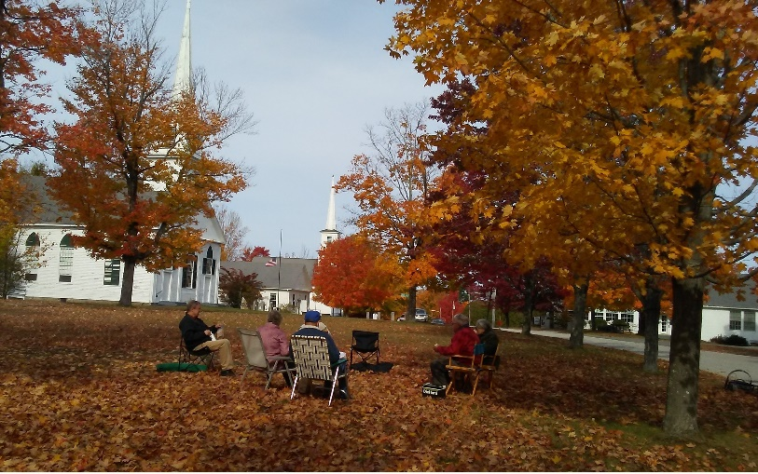

As of October, the National Board of Directors had an opening, in case you are interested. The Board has also changed some rules for National meets. They should be in the next National POC bulletin.
The National meet in Springfield , ILL was cancelled and has been rescheduled for June of 2021.

Sadly, because of Covid, we will not be having our annual Christmas gathering . The situation seems to be getting worse instead of better. Jane Palmer says they have been hosting this party for over 20 yrs. We are even cancelling some family holiday gatherings. The club will not make any plans for the annual dinner meeting in February, it will be wait and see. We considered using ZOOM for a meeting but decided it would only include a small number of members. Let’s cross our fingers and pray this nightmare ends soon.

NOW FOR THE GOOD NEWS: Your officers have decided to WAIVE the DUES for 2021. Since we only spent money on 1 meeting and are sending out 6 newsletters, and not every month, it was an easy decision.
So, please stay safe, follow the guidelines, and have a nice holiday season. The next newsletter will probably be at the end of January.

Judy
Colonial Region Website – www.plymouthcarclub.com
President-Judy Whitman, 3326 Hancock Rd., Hancock, Mass. 01237 (413-738-5322) gvebigman@gmail.com
Vice President- Bruce Nichols, 33 Beach St. , Millbury, MA. 01527 (508-865-2238)
Secretary- Jane & Donald Palmer, 184 Buff Cap Rd., Tolland, Ct. 06084 (860-875-0022) 184palmer@comcast.net
Treasurer- Judi Nichols, 33 Beach St., Millbury, Ma. 01527 (508-865-2238)

