December 2019 Colonial Region Holiday Meet
Pictures of the Meet include:
“Turn Here” Indicator especially for new members attending their first Region Holiday Meet includes Colonial Region large poster:
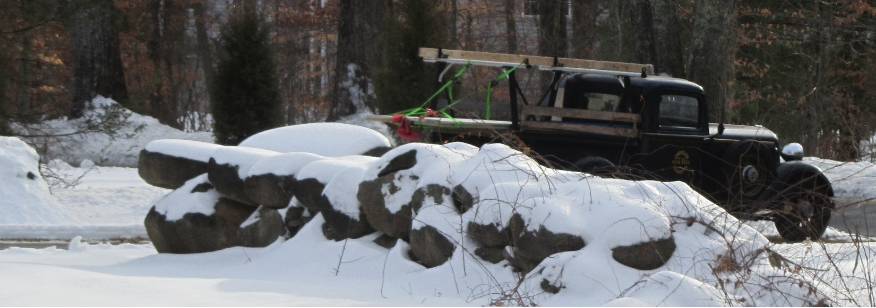

Line up of Region Member’s Modern Cars when winter conditions abound:

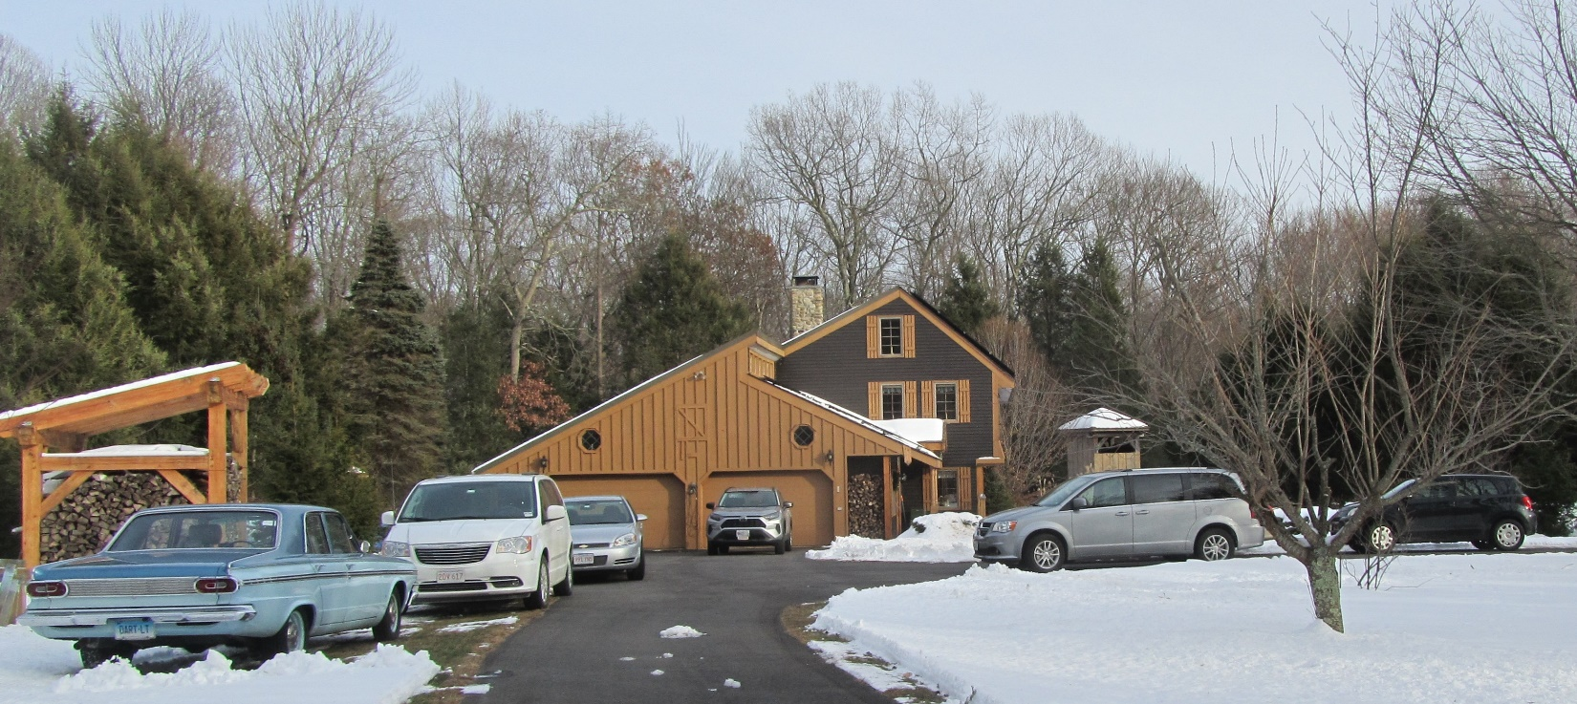

Freshly Cooked Turkey gets its own brightly colored carving table as well as display platter:
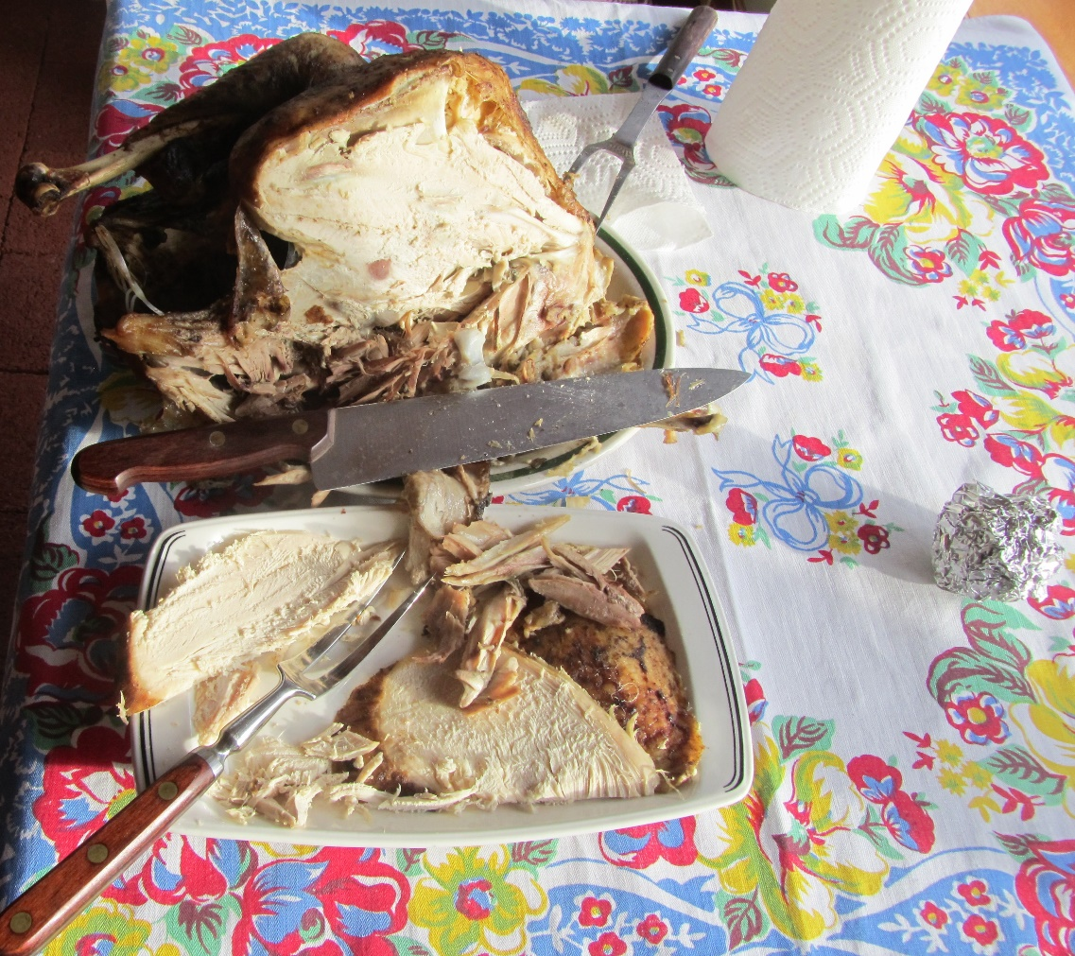
Pot Luck luncheon provides a large assortment for the palette:
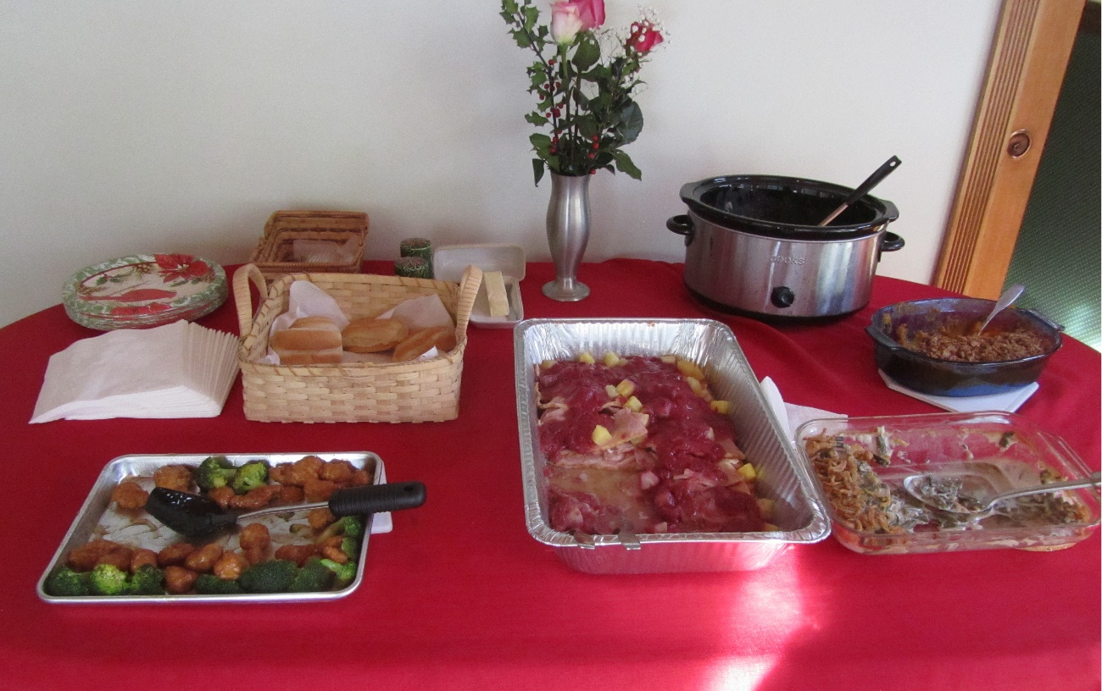
President conducts short business meeting that includes election of officers:
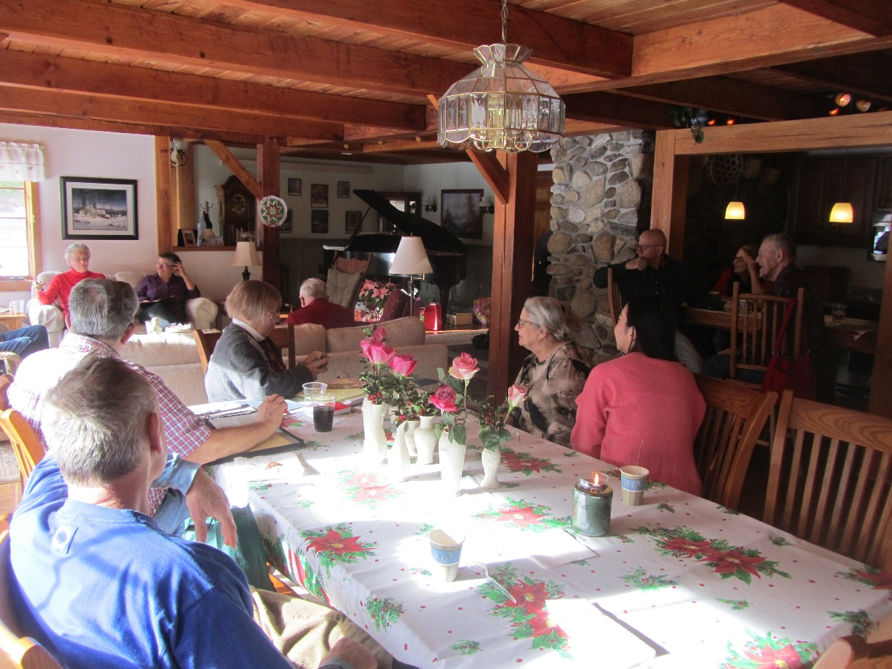

Vice President provides some data for the attendees:
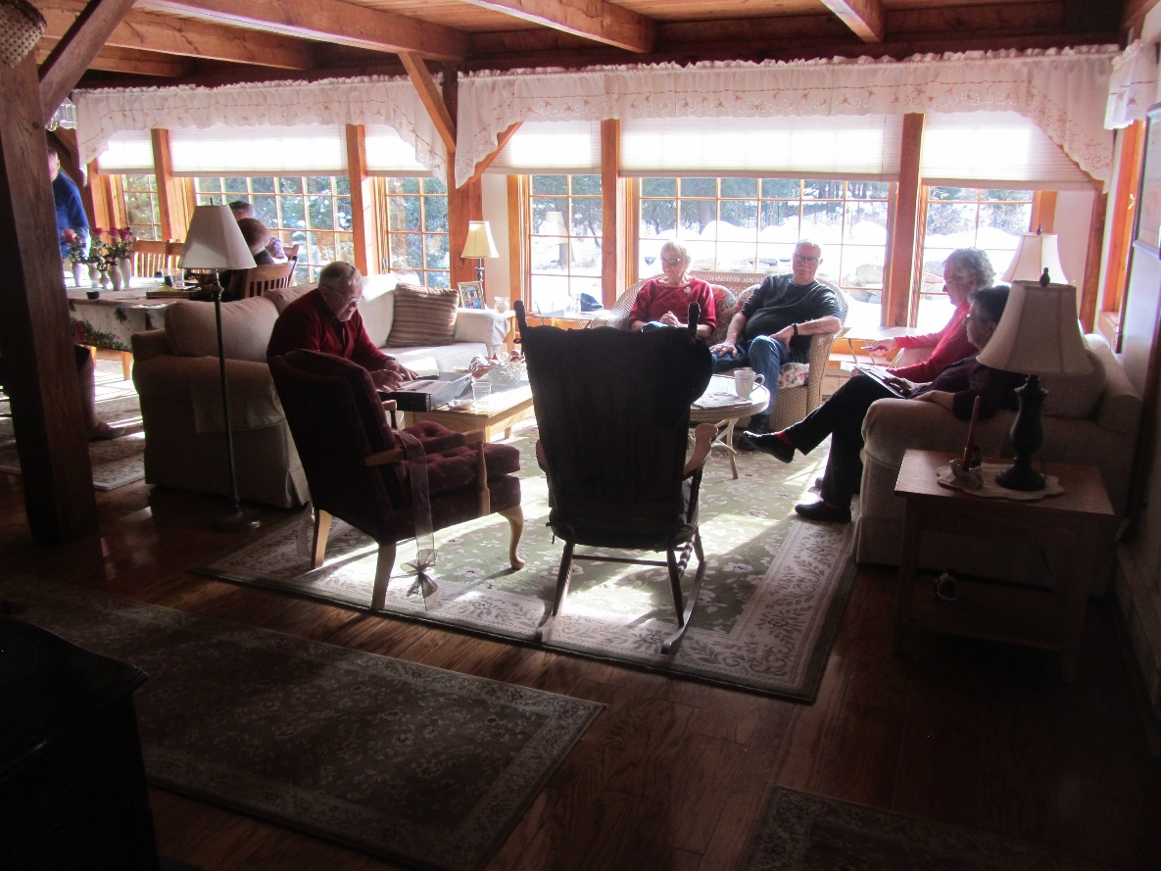

Grab bag gift process in motion provides some lively interaction:
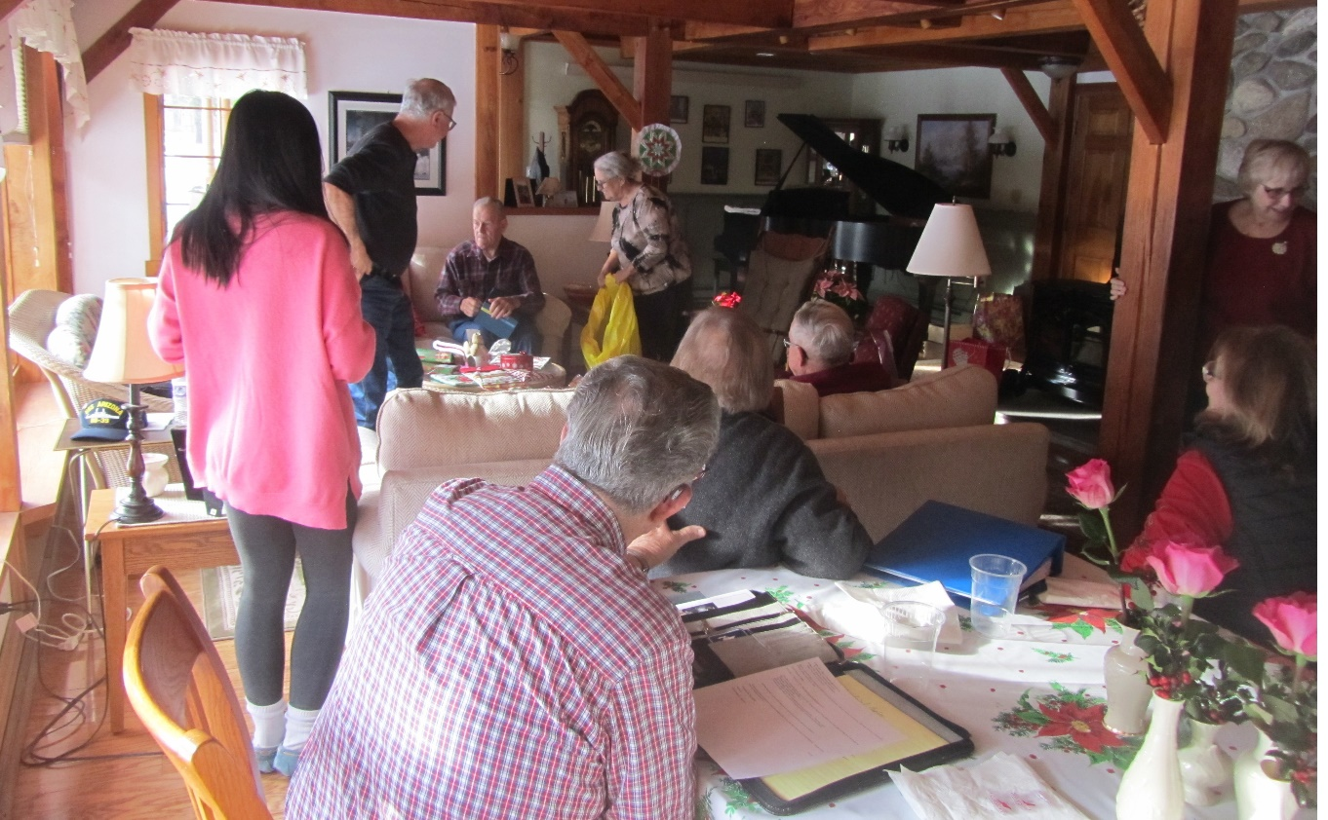

President tries stimulating faster gift opening process by her other half but……..:
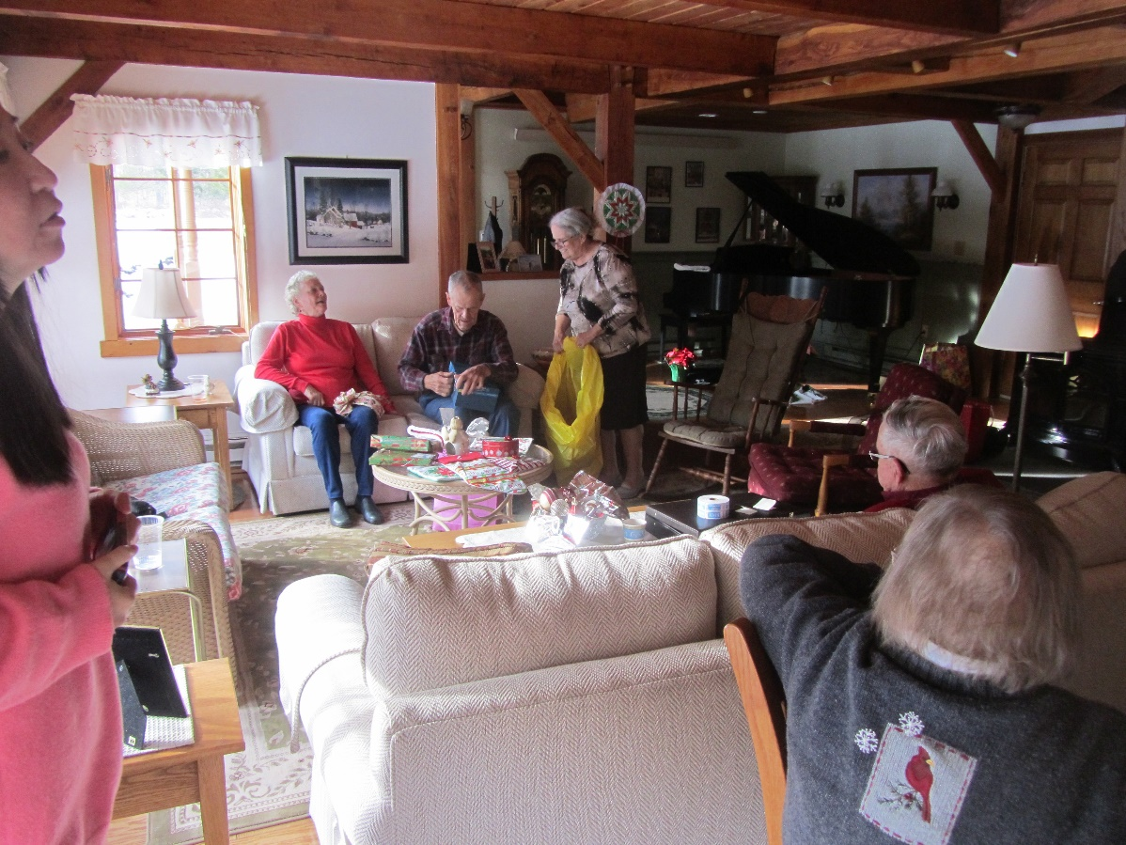
Special gifts for the ladies were vases & flowers:
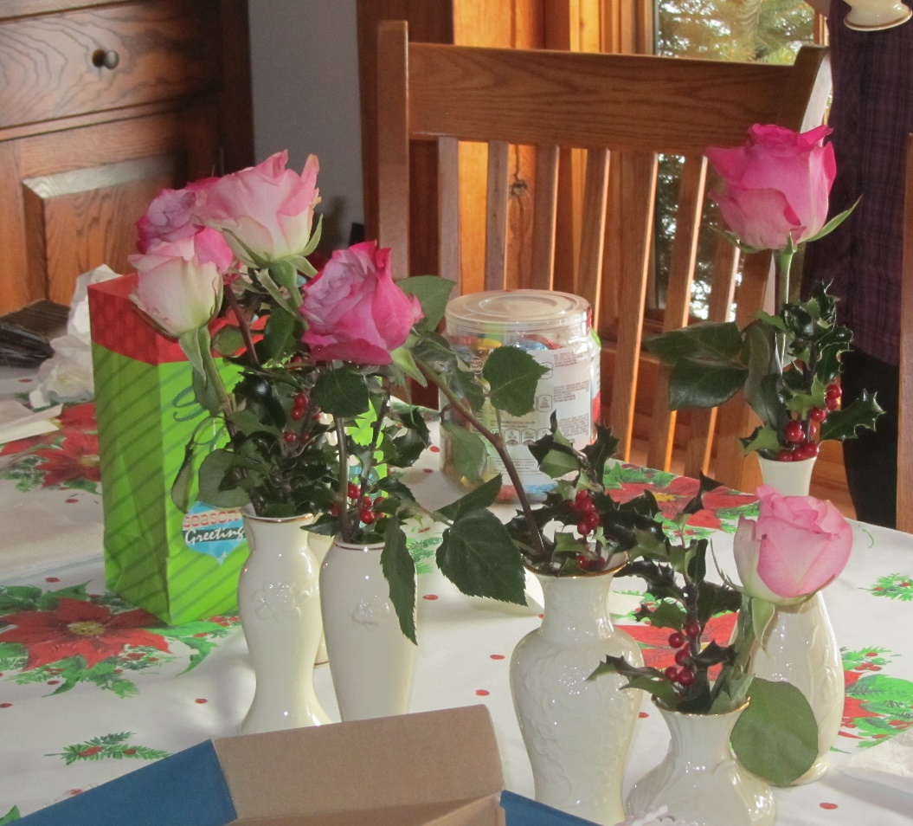

Pot Luck Desserts were the last event & were spread out for member selection process:
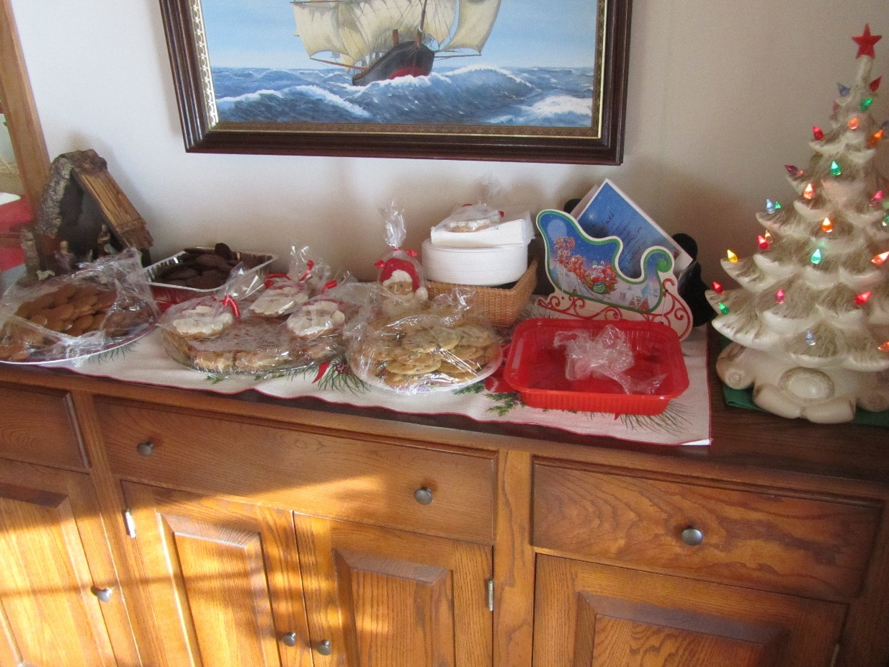

D. Whitman studied all the selections for quite some time:
