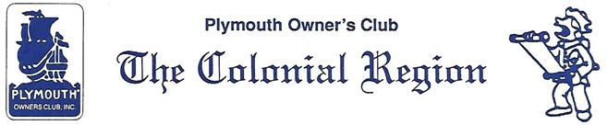
Secretary Minutes
COLONIAL REGION PLYMOUTH CLUB MEETING: December 8, 2019
Members present: Whitmans, Palmers, Crooks, Ruops, Nichols, Dunleas, Michniewiczs.
Richard, from the Hudson Valley Region, contacted Judy asking if we are involved in the Ply. 400 event. Bruce says there will be a parade with antique cars & he will watch for activities.
The Mattocks reported that they had attended the 4 cyl. tour & enjoyed it. The Lincoln Land Region will be hosting a 2020 Meet.
Judy mentioned that the Colonial Region will be 50 years old in 2024. Bruce suggested that we start thinking about what we would like to do.
Elections were held with the following results:
President: Judy Whitman
Vice President: Bruce Nichols
Secretary: Jane and Don Palmer
Treasurer: Judi Nichols
Don Palmer discussed that the pictures being sent, when being used by Lanny for the Bulletin, were not of good enough quality. He feels that pictures should be taken with a real camera rather than a phone because the quality is poorer when they are transferred.
The next Region event will be on February 23 at Noon at the Public House in Sturbridge, MA. A motion was made that the Club pay for half the meal: member $15.00, Club $15.00. The meal selection is a turkey dinner or Yankee pot roast. Anyone interested in attending should send their meal selection and a check made out to the Colonial Region Plymouth Club for $15.00 to Jane Palmer, 184 Buff Cap Road, Tolland, 06084 by February 14, 2020.
The calendar of events will be discussed at the February meeting.
Respectfully submitted,
Jane Palmer, Secretary

