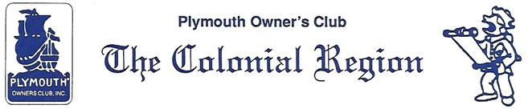
Secretary Minutes
COLONIAL REGION PLYMOUTH CLUB MEETING: August 18, 2019
Members present: Whitmans, Palmers, Crooks, Ruops (plus guests Ryan and Melissa).
There was no Secretary’s Report or Treasurer’s Report. One of our former members, Dick Crowell, passed away. New member Rivke Reid wrote a letter indicating her interest in becoming more active in our club. Bruce recruited a new member.
Robert Selkowitz, who led our tour in the Catskills, wrote a letter thanking us for participating with him on the tour. He organizes historic tours, if anyone in the Club is interested.
Don Palmer discussed the website. There is a 1939 Plymouth convertible coupe, located on the NY/MA line, being advertised. Someone interested in the coupe was looking to see if any Region members knew anything about the car. Most of the activity on the website involves Robo messages of people selling non-car related things.
Elections will take place this year. If anyone is interested in being the coordinator of elections, please let Judy know.
Our next meeting will be at Jim and Qin’s farm in Woodstock, CT on Sept. 15. We will go to Water’s Farm Days on October 20. Lunch at the Chicken Farm will be in November (date to be determined). The Christmas party will be at the Palmer’s on December 8.
Respectfully submitted,
Jane Palmer, Secretary

