“Engine & Secondary Ignition Physical Part 3” restoration article is inspired by the upcoming May 2019 “Tech Event” being hosted by the Nichols at their home.
Part 1 covered the need for having ignition data on your unique vintage car, getting a routine “physical” to collect present data, & finally delved into some secondary ignition resistances:
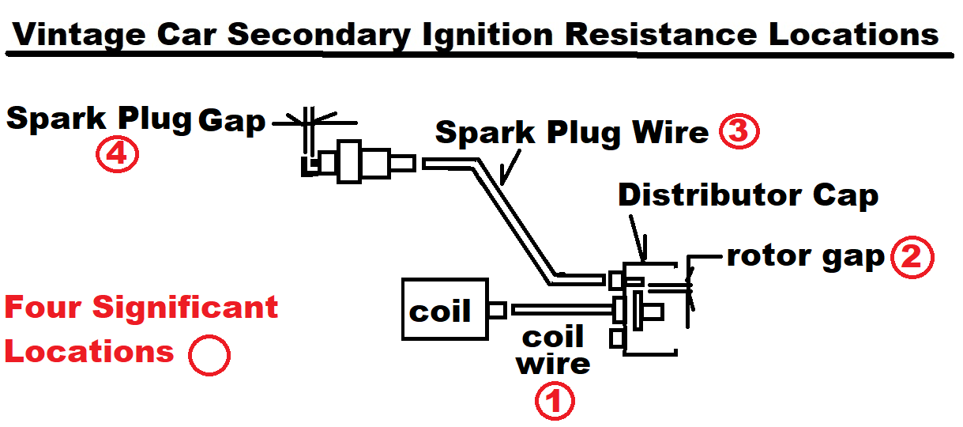
Part 2 covered the importance of inspecting Secondary voltages & one cause of excess voltage.
Part 3 covers applying this knowledge to an example; 65 Dart(Slant Six) with excess secondary voltage measured in the 2018 Engine Secondary Ignition Physical. Applying the theory of only changing one thing at a time the 2019 65 Dart Ignition Physical was performed (Trail 1) after altering the design of the spark plug wires by changing wire types & altering routing for the unique slant 6. Wire types originally were 8.5mm EMI & were changed to 8.5mm non EMI:
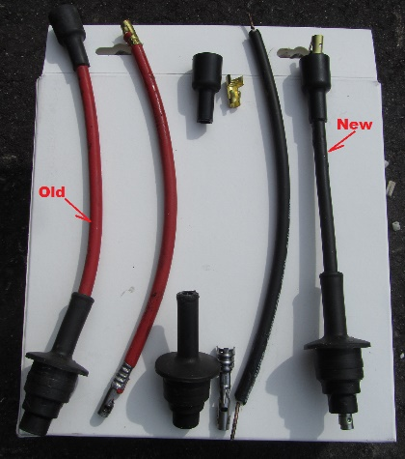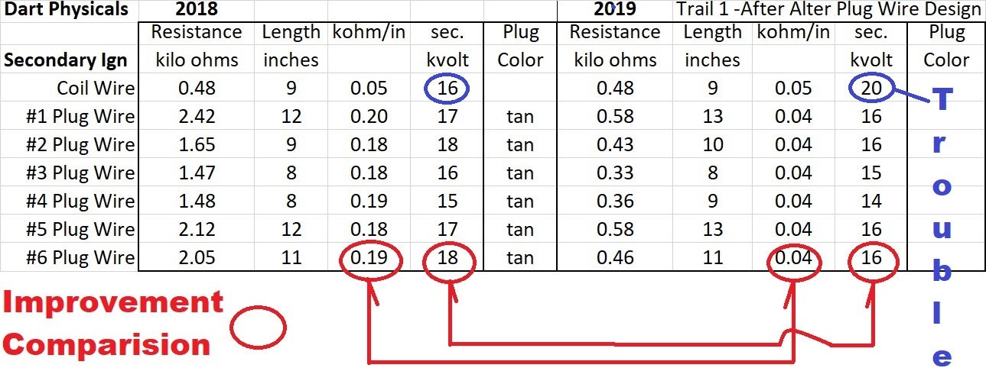
Plug Wire Secondary Voltage dropped 10% which is not enough; this points to the plug itself as needing attention (plug resistance downstream of our plug wire Volt measurement is suspect).
Also note that over the course of the year the coil wire voltage is showing increases even though plug wire resistances had dropped. Something else must also be going on and the distributor cap terminal to rotor condition looks suspiciously high on the list of items to exam.

