Colonial Region
New England experienced an unusually warm and dry November and December with salt-less roads allowing region members to use their Plymouths right up thru Christmas. Green grass and buds on the pear tree added the feeling of Spring in the air but blowing leaves whispered otherwise. The 61 Fury went for a ride on Christmas Day in Western Massachusetts!
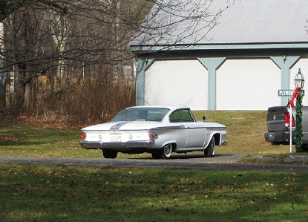
Sunday, December 6, found 15 members at the yearly Region Christmas Party at the Palmer’s with perfect weather, lots of good food, many tasty gifts, and great company.
Region yearly dues were collected from those present (dues remain at $15 per family). Members not present can send a check to Judi Nichols at 33 Beach St., Millbury, MA. 01527
The short formal meeting covered future events, approval of Secretary previous minutes, and election results. Detailed information is available in the President's and Secretary Message at our website plymouthcarclub.org.

Future Events: Bruce and Judi Nichols will host the February 21 noon event at their home in Millbury on that Sunday with a photo and memorabilia display of Club tours and meetings (last year they had 3 feet of snow but hopefully El Nino will change that issue this year).
The March meeting will be our annual business meeting at the Whitman home in Hancock on Sunday March 20 at noon with lunch at the IOKA Valley Farm (Pancakes, French toast, waffles(no eggs), real maple syrup, and maple ice cream).
May 14th (a Saturday) is being planned by Bruce at the Thompson Speedway motorsports park in Thompson Conn. It will include a car show, tour, driving your Plymouth on the track, lunch in the clubhouse, and a club meeting in the media room.
Help plan June outward activities.

Election Results: President-Judy Whitman, Vice President-Doug Crook, Treasurer-Judi Nichols, Secretary-Palmers.
- Don and Jane Palmer

