Event: Colonial Region June 2015 Tour - June 13 and 14.
A Taste Of The Blackstone River Valley - Today & Yesterday
First Stop- Pawtucket Visitor's Center (after the eating!)
Sights and Sounds- Movie on 150 years of the region's growth, tour of a Slater's Mill Complex with antiquated water wheel, machine shop, cotton prep and linen equipment in action.
Background:
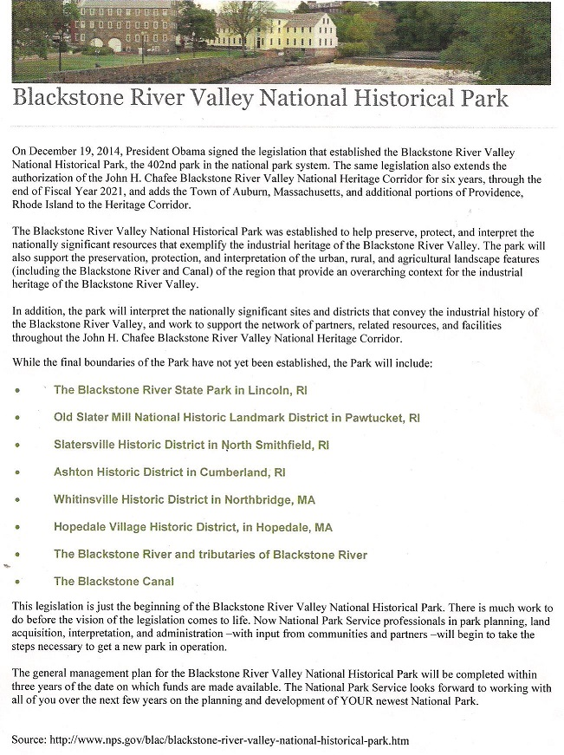
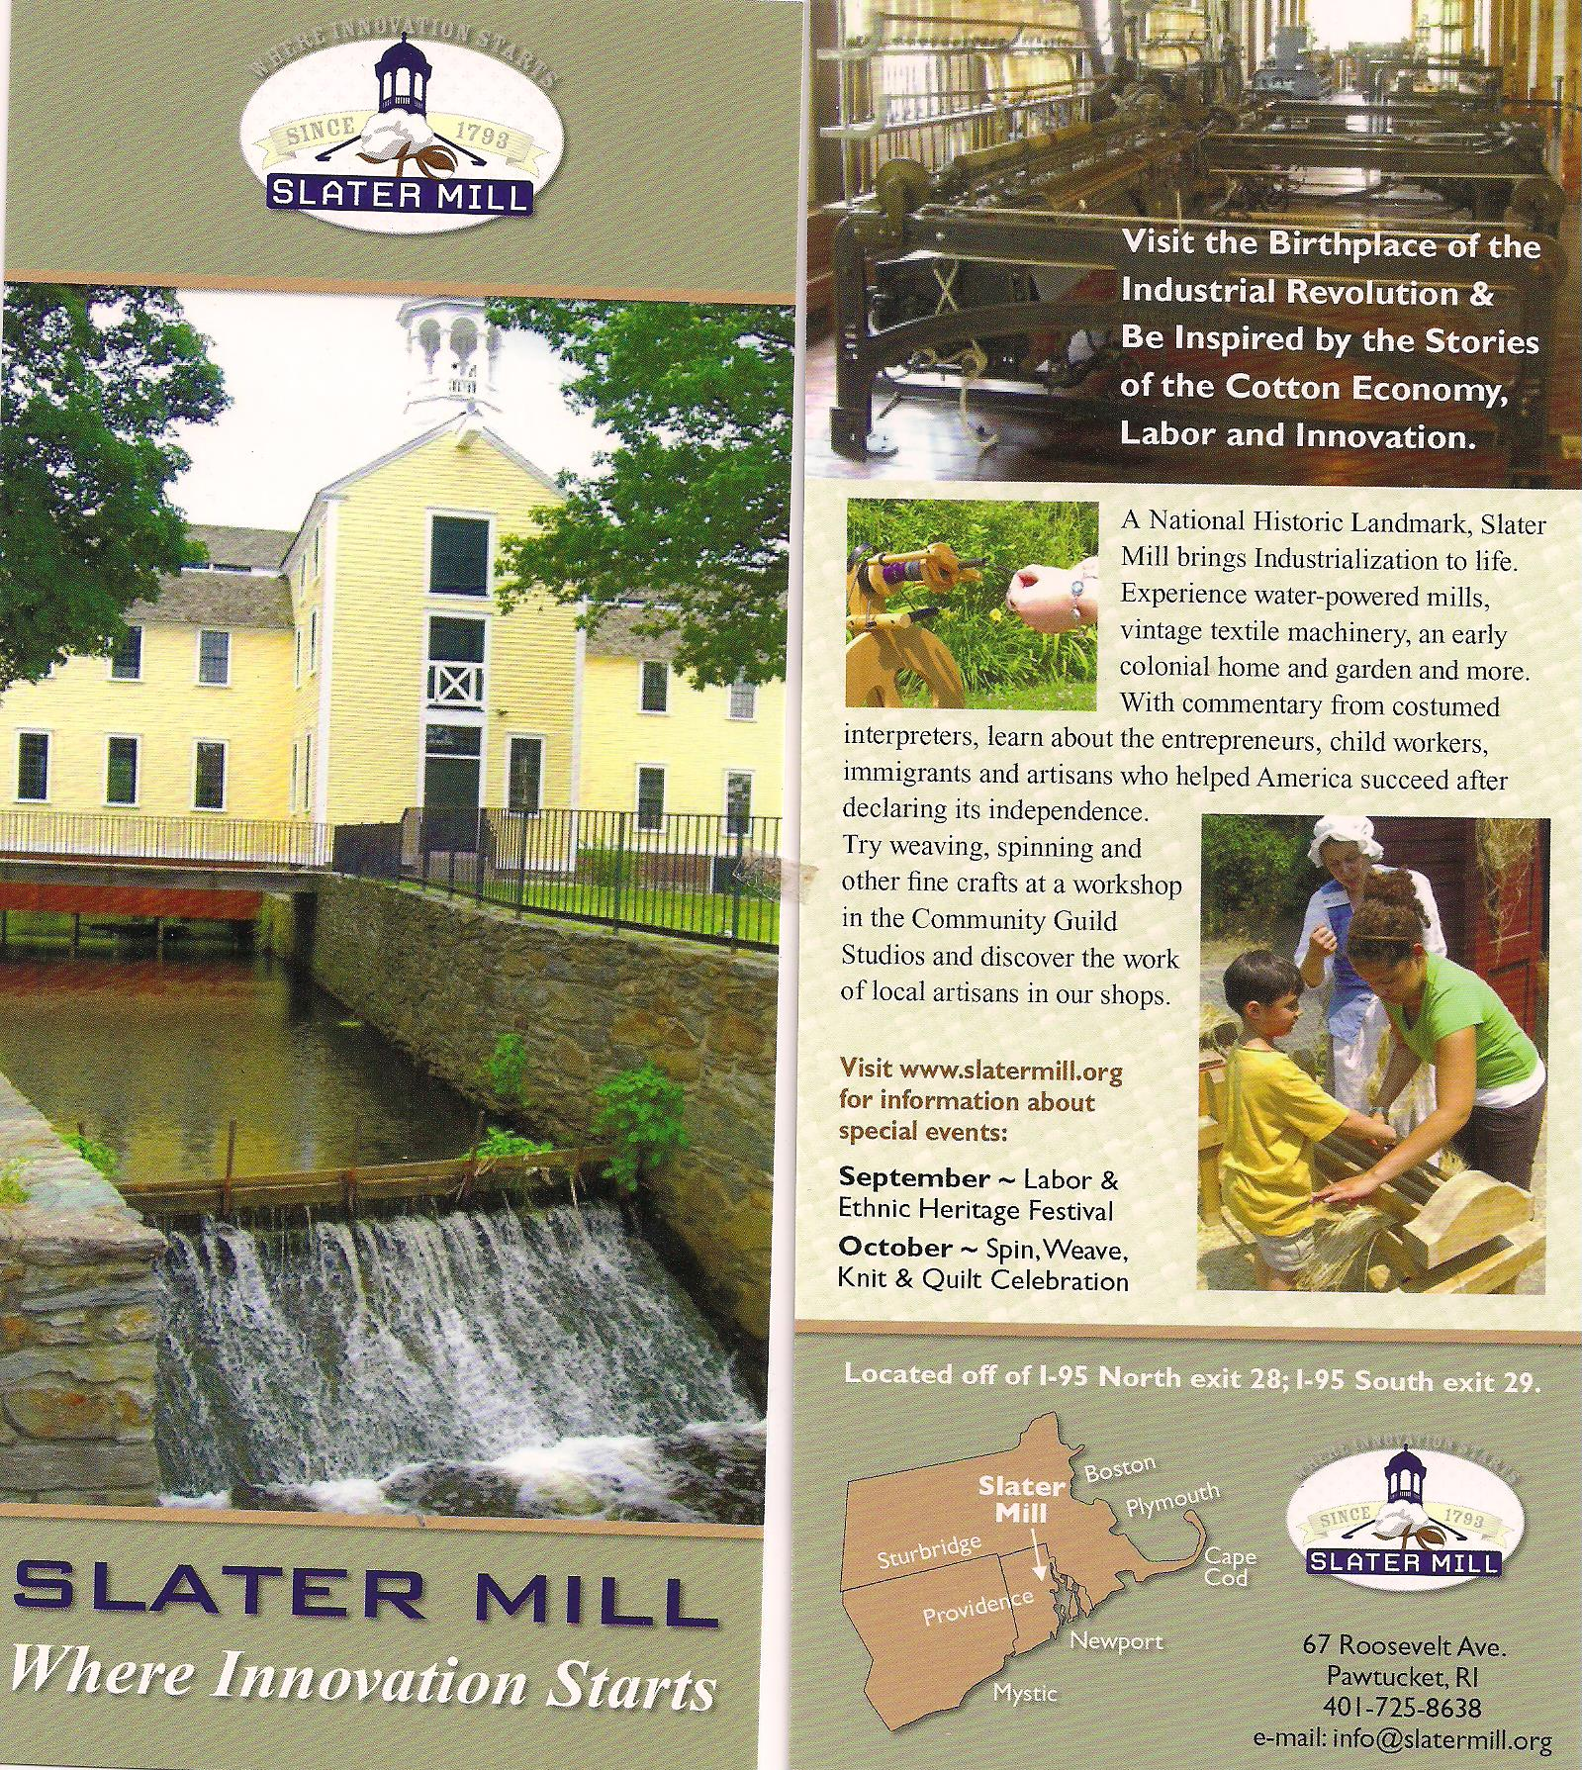
Then it's off to more eating in Providence right on the river.
Finally at dusk the big event in Providence where gondola and pontoon rafts with cocktail tables and wine galore (even a just married couple in their wedding attire) cruised a long stretch of the river with....wait for it......
Water & Fire
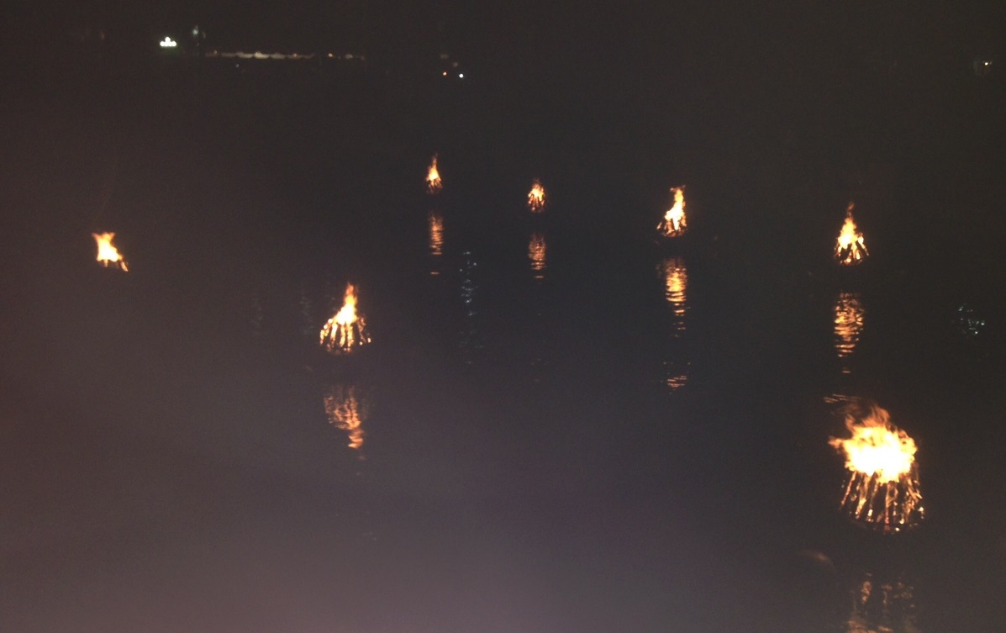
Back to Pawtucket & next morning it was off to a flea market:
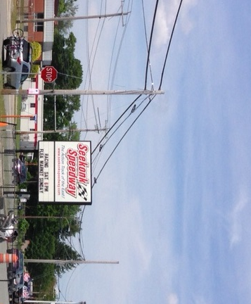
Off to Our Own Guided Cruise On The River
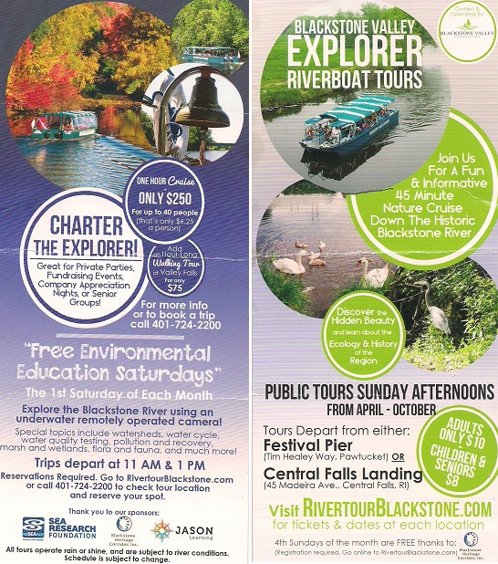

Finally in true Colonial Region fashion we captured the tour highlights with the normal Colonial Region stop for Ice Cream on a beautiful sunny day; this time at Friendly's.

